# Help end homelessness:

# Use ArcGIS Pro to build data-driven solutions for combating homelessness

Author: Lauren Scott Griffin, ESRI

Duration: 2hr(s) 30mins

This case study was designed to help cities, counties, and other jurisdictions build powerful analytical tools for addressing homelessness. By completing this lesson, you'll learn how to create a homelessness risk map, explore spatial patterns of various risk factors, and compare characteristics among different homeless communities. You'll also learn how to weigh different planning scenarios to decide where to locate new resources. You can start with the data provided and repeat the workflows using your own data.

**Workflow**

Part 1. Create a risk map

Predict where people are becoming homeless. 30 minutes

Part 2. Prioritize prevention

Find the best locations for targeted prevention. 30 minutes

Part 3. Map homeless communities

Map homeless community characteristics and their needs. 30 minutes

Part 4. Promote consensus

Determine the best locations for investment in new resources. 1 hour

**Part 1: Create a risk map**

A comprehensive plan to address homelessness includes programs to prevent homelessness before it starts and programs to support people already experiencing homelessness. This lesson focuses on prevention. It answers the question: where are people in Los Angeles County becoming homeless?

Prevention is much less costly than dealing with the complications of long-term homelessness. To prevent homelessness, however, you must know where it begins. The [point-in-time count data for Los Angeles County](https://www.lahsa.org/homeless-count/home) indicates where homeless people are, not where they were when they became homeless. You'll predict where people are becoming homeless based on [key factors known to contribute to homelessness](https://nationalhomeless.org/about-homelessness/). These factors include poverty, addiction, lack of affordable housing, unemployment, mental illness, domestic violence, and high health care costs. For this analysis, you'll give all factors equal weighting.

**Step 1: Open the project**

First, you'll download and open an ArcGIS Pro project containing demographic data relevant to homelessness.

1. Download the [homeless-data compressed folder](http://downloads.esri.com/learnarcgis/combat-the-homelessness-crisis/homeless-data.zip). [It is also accessible on Canvas]
2. Right-click the downloaded folder and extract it to a location you can easily find, such as your Documents folder. [Be mindful of the directory you use, especially if using CSDE]
3. Open the homeless-data folder.

The folder contains a file geodatabase (.gdb) with data, an index file, an ArcGIS Pro project file (.aprx), and an ArcGIS toolbox (.tbx).

1. If you have ArcGIS Pro installed on your machine, double-click the Homelessness ArcGIS Project File (it may have an .aprx extension). If prompted, sign in using your licensed ArcGIS account.

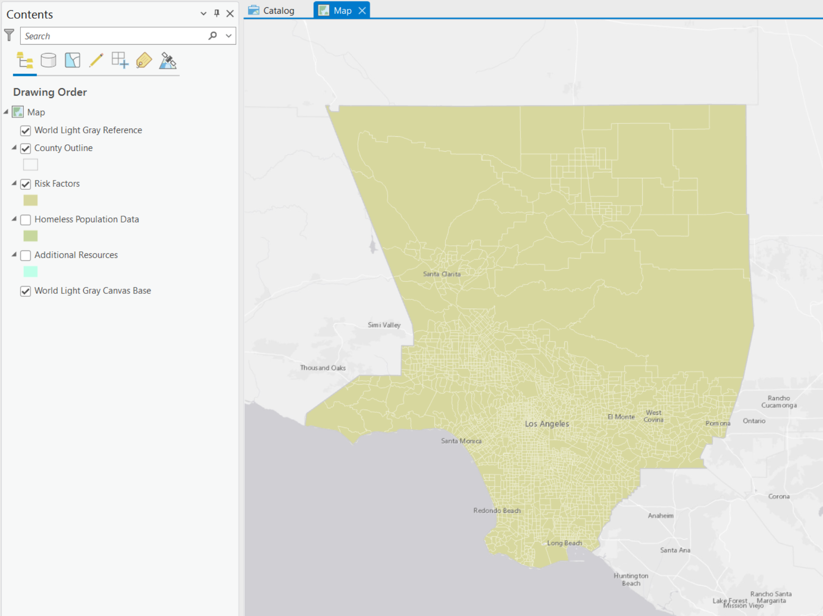

The project contains a map of Los Angeles County. Besides the basemap, it has four layers, one of which is the county outline. The other three layers contain the county's census tracts with different types of demographic information as attributes.

For now, you're only interested in homelessness risk factors.

1. In the Contents pane, right-click Risk Factors and choose Attribute Table.

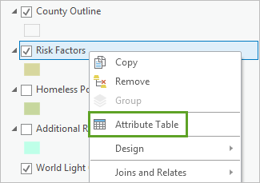

The table opens. For each census tract, it contains demographic information about income, mental illness, substance abuse, and other factors that can lead to homelessness. This information was obtained using the [Enrich](https://pro.arcgis.com/en/pro-app/tool-reference/analysis/enrich.htm) tool and was converted into rates where appropriate. Post-traumatic stress disorder (PTSD) among veterans was estimated using American Community Survey (ACS) veteran data and PTSD prevalence data. Prevalence of severe mental illness was computed using [Esri demographic data](https://www.esri.com/data/esri_data) and mental illness prevalence data. Domestic violence incidents were extracted from the Los Angeles County Sheriff's Department [crime incident data](https://lasd.org/transparency/crimeandarrest/). Data indicating change (in unemployment rate, for example) was obtained from [past ACS data sources](https://www.census.gov/data/developers/data-sets/acs-5year.html).

1. Close the table.

**Step 2. Copy a census tract**

As you saw in the table, there are many risk factors for homelessness. You could symbolize the layer to show an individual risk factor, but to predict where people are becoming homeless, you'll need to consider all risk factors at once.

To make your risk map, you'll create a hypothetical census tract that has the worst values found across the county for each risk factor. Then, you'll rank all census tracts by how similar they are to the worst-case tract. Doing so will give you a picture of homelessness risk across the county.

First, you'll copy an existing census tract to be the base for your hypothetical tract.

1. In the Contents pane, uncheck the County Outline layer.

With the outline turned off, it'll be easier to select features in the Risk Factors layer.

1. On the ribbon, click the Map tab. In the Selection group, click the Select button.

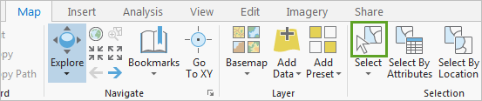

1. On the map, click any census tract (it doesn't matter which).

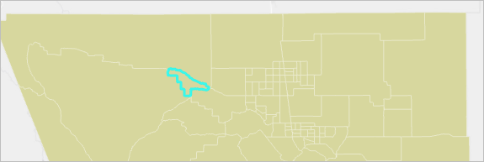

1. In the Contents pane, right-click Risk Factors. Point to Data and choose Export Features.

Alternatively, in the Geoprocessing pane, open the [Feature Class to Feature Class](https://pro.arcgis.com/en/pro-app/tool-reference/conversion/feature-class-to-feature-class.htm) tool. This tool creates a copy of a feature layer. If one or more features of the layer are selected, only the selected features will be copied.

1. For Input Features, confirm that Risk Factors is chosen. For Output Feature Class, change the output name to Target_Tract.

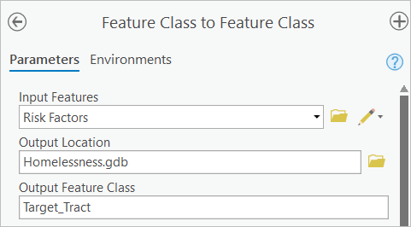

1. Click Run.[OK]

The Target_Tract layer is added to the map and the Contents pane. The copied tract overlaps with the original tract, so you can't see it. You'll edit the copied tract to move it outside of the study area.

1. Turn off the Risk Factors layer. Use the Select tool to select the copied census tract.
2. On the ribbon, click the Edit tab. In the Tools group, click Move.

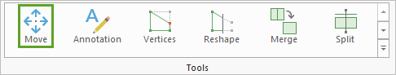

1. Drag the selected census tract outside of Los Angeles County.

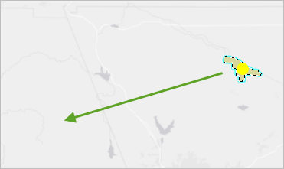

**Tip:** The basemap contains a faint outline of the county. If you have difficulty seeing the outline, you can turn the County Outline layer back on.

1. At the bottom of the map, click Finish.

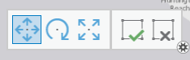

**Tip:** Pressing the F2 key will also finish the editing session.

1. On the ribbon, in the Manage Edits group, click Save.

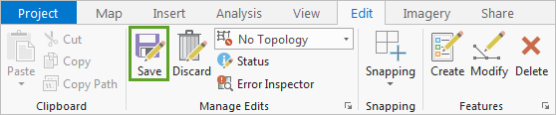

The Save Edits window opens, asking you to confirm that you want to save your edits.

1. Click Yes.
2. Close the Modify Features pane.
3. Turn on the County Outline and Risk Factors layers. On the ribbon, in the Selection group, click Clear.

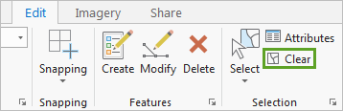

The selected feature is cleared. Your map shows the original census tracts and your new target tract.

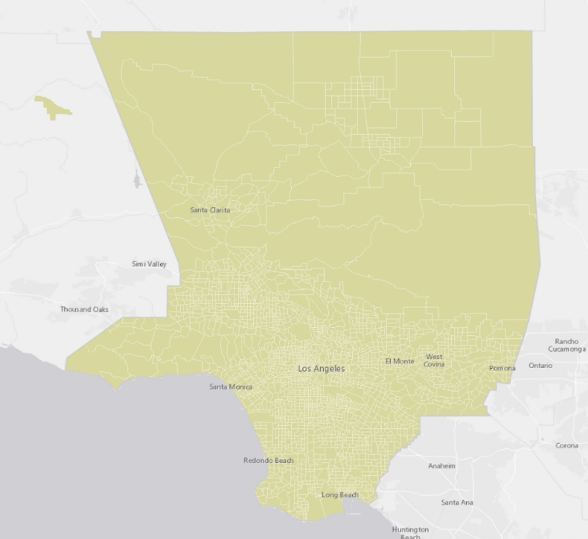

**Note:** It's possible that the Move editing tool is still active. If you want to navigate the map, click the Map tab. In the Navigate group, click Explore.

1. On the Quick Access Toolbar, click the Save button to save the project.

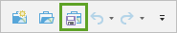

**Step 3. Edit attribute data**

Next, you'll edit the attribute data of the target tract so that it contains the worst values countywide for each homelessness risk factor.

1. Open the attribute tables for the Target_Tract and Risk Factors layers.

Both layers contain a field named 2017 Total Population. While this field gives useful context, it isn't a risk factor. You'll delete it from the table.

1. In the Target_Tract table, right-click the 2017 Total Population field (near the end of the table) and choose Delete.

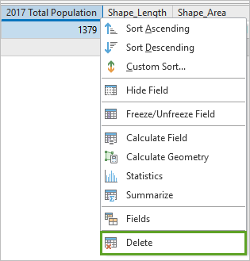

1. In the Delete Field window, click Yes.

The field is deleted. Next, you'll edit the remaining fields. Currently, you can only view one table at a time. You'll need to compare the tables frequently, so you'll rearrange them in order to view both at once.

1. Drag the Risk Factors table tab to reposition it above the Target_Tract table.

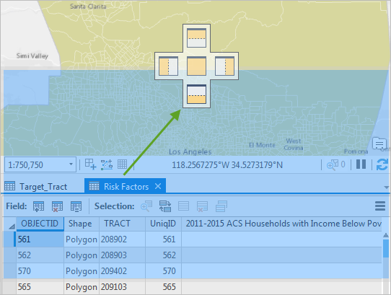

The tables are displayed one above the other.

**Tip:** You can rearrange either table in any position you prefer. The objective is to be able to view both tables at once.

1. In the Risk Factors table, right-click the 2011-2015 ACS Households with Income Below Poverty Level field and choose Sort Descending.

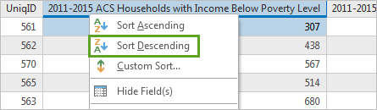

**Tip:** Alternatively, double-click the field name to sort from smallest to largest. Double-click a second time to sort from largest to smallest.

The field is sorted from the largest to smallest value. The highest number of households with income below the poverty level is 1,809. This is the worst value in the county, so you'll edit the Target_Tract table accordingly.

1. In the Target_Tract table, double-click the value for the 2011-2015 ACS Households with Income Below Poverty Level field to edit it. Type 1809.

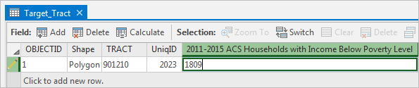

Normally, you would repeat the process for all other risk factors. For the purposes of this exercise, you'll be provided the remaining worst-case values.

1. Edit the Target_Tract table with the following values:

**Tip:** Press the Tab key to quickly switch to the next field.

* + 2011-2015 ACS Percent of Households with Income Below Poverty Level: 100
  + Change in number of HH below poverty level 13-17: 311
  + ACS HHs w/Public Assist Income: 525
  + ACS % HHs w Public Assistance Income: 42.40711
  + Change in number of HH w Public Assistance 13-17: 145
  + ACS HHs w/1+ Persons w/Disability: 1068
  + ACS % HHs w 1+ Person w Disability: 100
  + ACS HHs/Gross Rent 50+% of Income: 1132
  + % HHs paying 50+% of income for rent: 100
  + Change in number of HHs paying 50+% of income for rent: 207
  + 2017 Unemployed Population 16+: 371
  + 2017 Unemployment Rate: 52
  + Change in Unemployment Rate 10-17: 52
  + No Health Insurance Pop 18+: 2760
  + % No Health Insurance Pop 18+: 74.94635
  + % Veterans with PTSD: 25
  + Est Veterans w PTSD: 92
  + Est Serious Mental Illness Cnt: 1004
  + Est % w a Serious Mental Illness: 12.5
  + Substance Abuse Incidents: 233
  + Substance Abuse Rate: 600
  + Domestic Violence Incidents: 91
  + Domestic Violence Rate: 4.545455

**Note:** Be sure to press Enter after changing the final value (otherwise you won't be able to save your changes).

Your target tract now has the worst values countywide for each risk factor.

1. On the ribbon, click the Edit tab. Click Save and click Yes to save all edits.
2. Close the Risk Factors and Target_Tract tables.
3. Save the project.

**Step 4. Rank tracts by similarity to the target**

Next, you'll run an analysis tool called [Similarity Search](https://pro.arcgis.com/en/pro-app/tool-reference/spatial-statistics/similarity-search.htm) to compare all census tracts to your target tract. The tool ranks tracts by how similar they are based on their attributes. The tracts with the smallest ranking will be those with the highest risk for homelessness.

1. On the ribbon, click the Analysis tab. In the Geoprocessing group, click Tools.

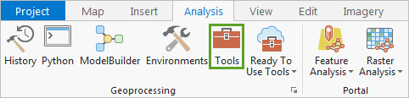

1. In the Geoprocessing pane, search for Similarity Search. Click the [Similarity Search](https://pro.arcgis.com/en/pro-app/tool-reference/spatial-statistics/similarity-search.htm) tool.

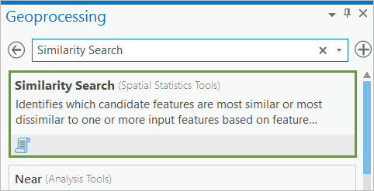

The tool's parameters appear. First, you'll choose the feature layers to compare.

1. For Input Features to Match, choose Target_Tract. For Candidate Features, choose Risk Factors.
2. For Output Features, change the output name to Risk_Surface.

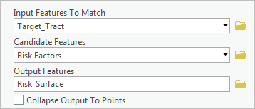

If checked, the Collapse Output To Points parameter creates a point feature layer instead of matching the existing geometry. You'll leave this unchecked so that your output retains the shape of the tracts.

The next two parameters determine how features will be ranked. You want to rank tracts that are most similar to the target tract feature based on attribute values.

1. For Most Or Least Similar, confirm that Most similar is chosen. For Match Method, confirm that Attribute values is chosen.

The next parameter, Number Of Results, determines how many features are ranked. If you enter 0, all features will be ranked.

1. For Number Of Results, type 0.

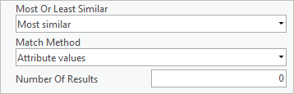

1. For Attributes Of Interest, click Select All. Uncheck UniqID, Shape_Length, and Shape_Area.

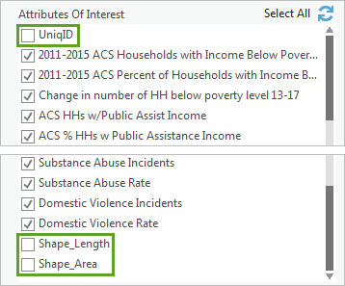

These three attributes aren't risk factors, so they shouldn't be part of the comparison.

Next, you'll append two fields from the Risk Factors layer onto the output layer. These fields will contain the name of each tract and its total population. You previously deleted the population field from the Target_Tract layer because it wasn't a risk factor, but you'll want to add it again after the risk factors are compared.

1. Expand Additional Options. For Fields To Append To Output, check TRACT and 2017 Total Population.

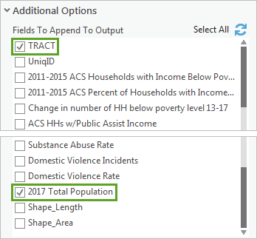

1. Click Run.

The tool runs and the output is added to the map.

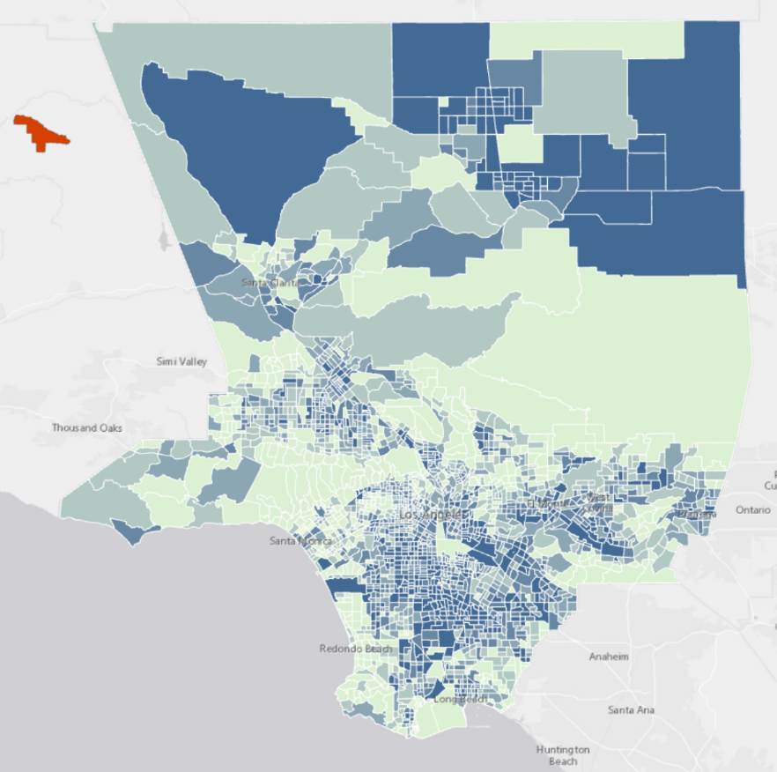

The darker blue tracts are those that are most similar to the target tract. Many areas with high risk for homelessness are located in the southern part of the county, which isn't too surprising because it coincides with the most urban areas of Los Angeles. However, there are also many high-risk tracts in the northern desert region, near Lancaster and Palmdale.

1. In the Contents pane, turn off the Target_Tract and Risk Factors layers. Drag the County Outline layer above the Risk_Surface layer.
2. Save the project.

**Step 5. Symbolize the tracts**

The default symbology is okay, but the larger census tracts in the north are emphasized more than smaller ones in the south. It would be better if tracts with higher population were emphasized instead.

Symbolizing each tract with a point feature that represents the tract's population might work, but in Los Angeles that would create many overlapping circles. Instead, you'll de-emphasize census tracts with small populations by increasing their transparency.

1. In the Contents pane, right-click the Risk_Surface layer and choose Symbology.

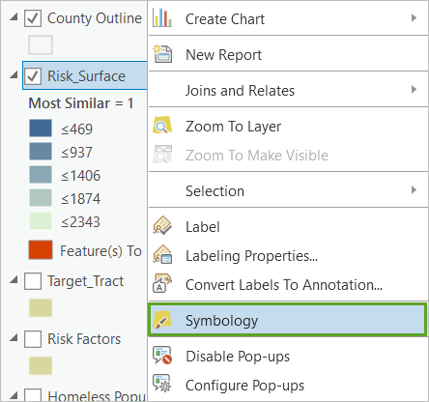

**Note:** You may receive a warning about an exclusion clause. The exclusion clause is for the target tract, which you'll later remove. You can ignore the warning.

First, you'll change the color scheme so there is a starker difference between the most and least similar values.

1. In the Symbology pane, for Color scheme, chose Purple-Red (5 Classes).

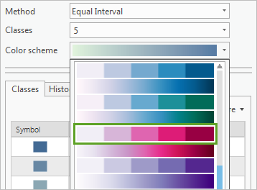

**Tip:** When you expand the Color scheme parameter, checking Show names displays both the color ramp and the color ramp name.

The color scheme is applied automatically. By default, the least similar features have the darkest colors, which isn't what you want.

1. For Classes, click More and choose Reverse symbol order.

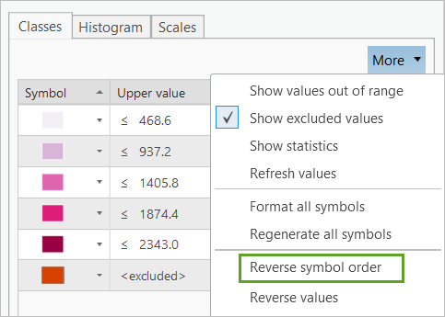

Tracts with more risk factors for homelessness have darker colors, while tracts with fewer risk factors appear white.

1. Click More again and uncheck Show excluded values.

The target tract no longer appears on the map. Another useful change to improve the readability of a map with many small features is to reduce the outline width.

1. Click More and choose Format all symbols.
2. If necessary, under Format Multiple Polygon Symbols, choose Properties. Change Outline width to 0.25 pt.

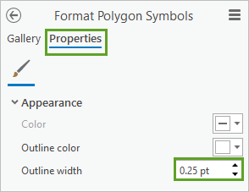

1. Click Apply.

The thinner outlines make the smaller features easier to see. Next, you'll adjust the transparency of tracts with low population to de-emphasize them.

1. In the Symbology pane, click the icon along the top for Vary symbology by attribute.

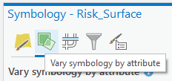

1. Expand Transparency. For Field, choose 2017 Total Population.

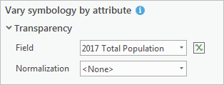

Transparency is automatically applied. Tracts with high population values have 30 percent transparency by default, while those with low population have 70 percent. It would be better if tracts with high populations had no transparency, so they stand out more.

1. Change High values to 0%.

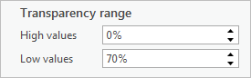

The range of transparency is still pretty broad, and only the highest population value has 0 percent transparency. You'll adjust the range so all tracts with a population higher than 8,000 have 0 percent transparency, while all tracts with a population less than 4,000 have 70 percent transparency. This way, differences between high and low values will appear more clearly.

1. On the graph of values, double-click the graph marker on 0 and type 4000. Double-click the lowest graph marker and type 8000.

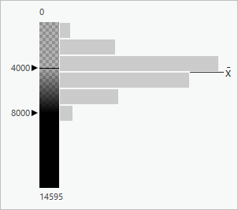

The graph includes a histogram of the values, so you have an idea of how many tracts will have more or less transparency. The transparency is applied automatically.

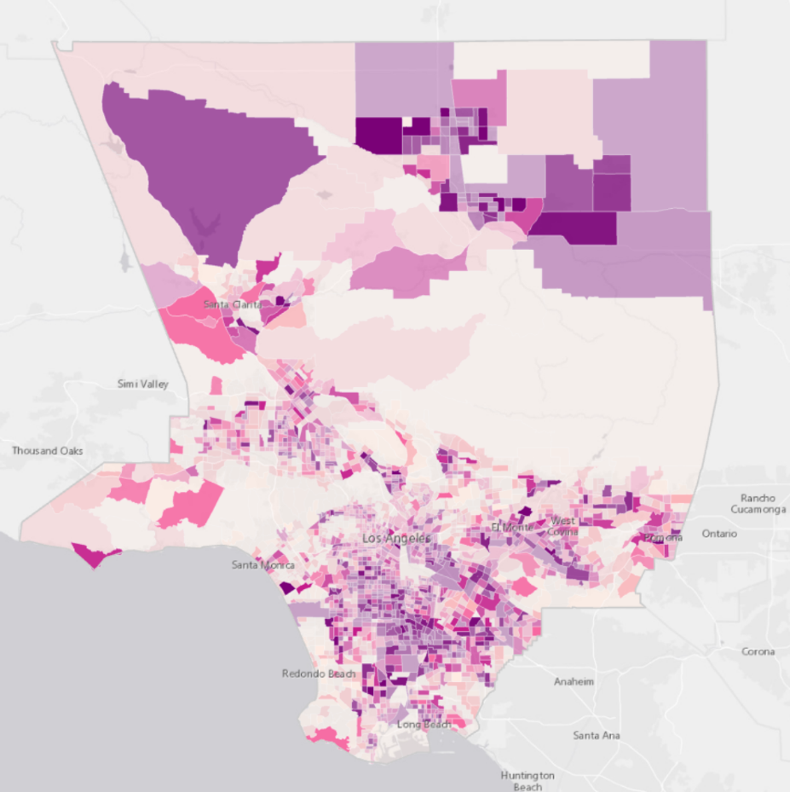

Now, the highest risk tracts with the largest population are emphasized. The map gives a better idea of the most important areas to target homelessness prevention.

1. Close the Symbology pane and any open tables. Save the project.

In this lesson, you created a map of census tracts in Los Angeles County with the highest risk for generating new homelessness. You then symbolized the map to account for tracts with more residents.

This workflow can be used to create any kind of risk map. Start by identifying the administrative boundaries you want to analyze (ZIP Codes, census tracts, or neighborhoods, for example) and gather available data for that area that reflects risk. The [Enrich](https://pro.arcgis.com/en/pro-app/tool-reference/analysis/enrich.htm) tool [provides data](https://la.arcgis.com/databrowser/index.html) for any administrative boundaries you choose. If some of your data is only available for other administrative boundaries, consider using the [sample apportionment tool](https://www.arcgis.com/home/item.html?id=73623e571150447f9058c462980054ee) or [Summarize Within](https://pro.arcgis.com/en/pro-app/tool-reference/analysis/summarize-within.htm) to distribute the data from one geometry to another (for example, ZIP Codes to neighborhoods). If you have point data (for example, crime incidents), use the [Spatial Join](https://pro.arcgis.com/en/pro-app/tool-reference/analysis/spatial-join.htm) tool to count the number of points within each polygon. If some of the risk factor data isn't available, consider estimating it (see [Mental Illness](https://www.nimh.nih.gov/health/statistics/mental-illness.shtml) and [PTSD](http://www.veteransandptsd.com/PTSD-statistics.html), for example). Don't worry if your data is incomplete; you can always repeat the analysis when additional variables become available. Move forward with what you have. The risk maps you obtain, even with partial data, will still be valuable.

In the next lesson, you'll identify the best locations for targeted prevention programs.

**Part 2. Prioritize prevention**

In the previous lesson, you analyzed all risk factors associated with homelessness to find the locations at highest risk for generating new homelessness. In this lesson, you'll analyze the spatial patterns of specific risk factors. Doing so will allow you to implement the right prevention programs in the right places, helping to ensure the best outcomes and the largest impacts.

This lesson answers the question: where will targeted prevention programs have their best chance of making a difference?

For the purposes of this exercise, you'll assume that Los Angeles County has decided to focus initial prevention efforts in two areas: unemployment and the lack of affordable housing.

**Step 1. Find top prevention program candidates**

You'll use the same target tract you created in the previous lesson. First, you'll rank tracts based on the unemployment risk factors. Then, you'll rank them based on the lack of affordable housing risk factors.

1. If necessary, open the Homelessness project in ArcGIS Pro.
2. Turn off all layers except the County Outline layer and the basemap.
3. In the Geoprocessing pane, search for and open the [Similarity Search](https://pro.arcgis.com/en/pro-app/tool-reference/spatial-statistics/similarity-search.htm) tool.
4. Enter the following parameters:
   * For Input Features To Match, choose Target_Tract.
   * For Candidate Features, choose Risk Factors.
   * For Output Features, type Unemployment_Project.
   * Uncheck Collapse Output To Points.
   * For Most Or Least Similar, choose Most Similar.
   * For Match Method, choose Attribute values.
   * For Number Of Results, type 25.
   * For Attributes Of Interest, check 2017 Unemployment Population 16+, 2017 Unemployment Rate, and Change in Unemployment Rate 2010-17.
   * For Fields to Append To Output, check TRACT.

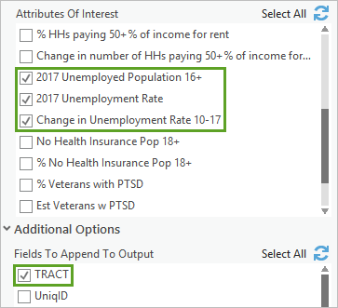

1. Click Run.

The tool runs and the output is added to the map. Twenty-five tracts with attributes similar to the worst-case target tract for unemployment risk factors are shown. The dark blue tracts are most similar, meaning they have the most severe unemployment risk factors. Later, you'll improve the symbology.

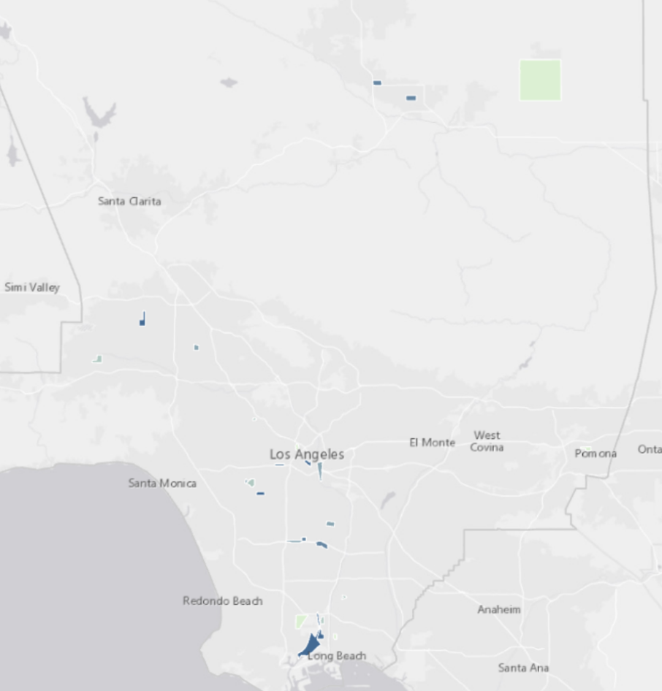

Access to affordable housing also plays an important role in the dynamics of homelessness, and [not just in Los Angeles](https://www.fastcompany.com/40504605/americas-affordable-housing-crisis-is-driving-its-homelessness-crisis). You'll use the [Similarity Search](https://pro.arcgis.com/en/pro-app/tool-reference/spatial-statistics/similarity-search.htm) tool again. This time, you'll identify priority locations for programs aimed at preventing homelessness by focusing on the lack of affordable housing.

1. If necessary, open the [Similarity Search](https://pro.arcgis.com/en/pro-app/tool-reference/spatial-statistics/similarity-search.htm) tool.

You'll use risk factor variables for households paying more than 50 percent of their total income for rent. It's possible that people choose rents they cannot afford, but it's more likely that they are paying more than 50 percent of their incomes for rent because affordable housing isn't available.

1. For Attributes Of Interest, uncheck the unemployment variables and check ACS HHs/Gross Rent 50+ % of Income, % HHs paying 50+ % of income for rent, and Change in number of HHs paying 50+ % of Income for rent. Change Output Features to Affordable_Housing_Project.
2. Click Run.

The tool runs and the output is added to the Contents pane.

1. Turn off all layers except the Affordable_Housing_Project layer and the basemap.

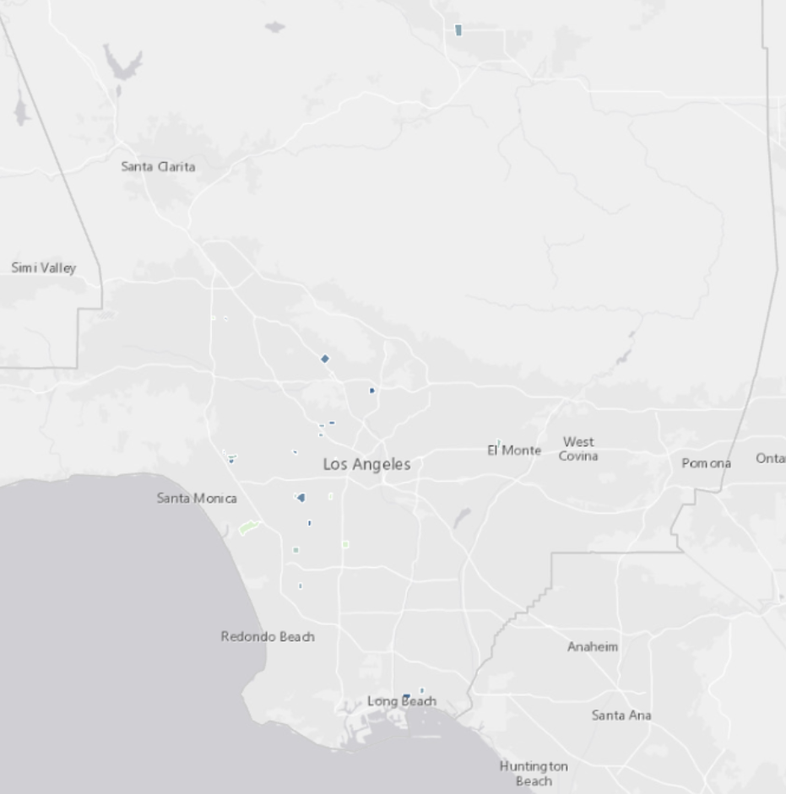

**Step 2. Symbolize program candidates**

Both the Unemployment_Project and Affordable_Housing_Project layers have 26 features, representing the 25 worst-case tracts for each project and the target tract. First, you'll delete the target tract record from each output so it doesn't appear in your final map. Then, you'll symbolize both layers using graduated symbols so the priority tracts are easier to see.

1. In the Contents pane, right-click the Unemployment_Project layer and choose Attribute Table.
2. Select the target tract record (the first record in the table with a MATCH_ID of 1).

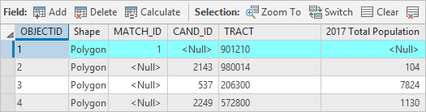

1. On the ribbon, click the Edit tab. In the Features group, click Delete.
2. In the Manage Edits group, click Save and click Yes when you are asked if you want to save all edits.
3. Delete the target tract feature from the Affordable_Housing_Project layer.

**Tip:** If the target tract still appears, click the Refresh button on the map.

The default symbology makes it difficult to see the smallest candidate project tracts. To improve the symbology, you'll use graduated symbols to reflect both location and the number of people, or number of households, potentially impacted if a prevention program is initiated. You'll create three categories (high, medium, and low) with an equal number of tracts in each category.

1. Close the tables.
2. In the Contents pane, turn on the Unemployment_Project layer. Right-click the layer and choose Symbology.
3. In the Symbology pane, change the following parameters:
   * For Primary symbology, choose Graduated Symbols.
   * For Field, choose 2017 Unemployment Population 16+.
   * For Method, choose Quantile.
   * For Classes, choose 3.
   * For Minimum size, choose 5 pt.
   * For Maximum size, choose 20 pt.

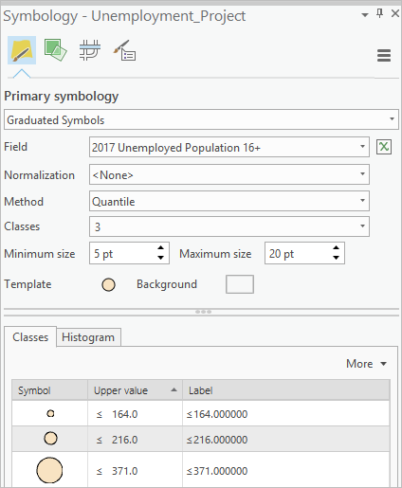

1. Click the Background symbol.

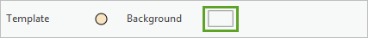

1. On the Properties tab, click the Layers button.

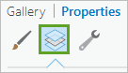

1. Select the Solid stroke symbol layer. For Color, choose No color.

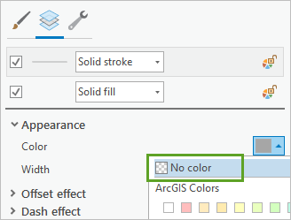

1. On the Symbology pane, click Apply. To return to the primary Symbology pane, click the Back button.

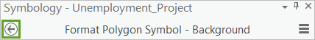

1. Click the Template symbol.

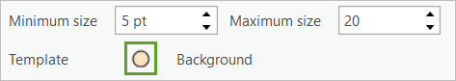

You'll also add a gradient effect to give the features a 3D appearance.

1. Change Shape fill symbol to Buffered gradient fill. For Colors, choose Malachite Green and Indicolite Green. For Outline color, choose Gray 40%.
2. Change Outline width to 0.5 pt. Click Apply.

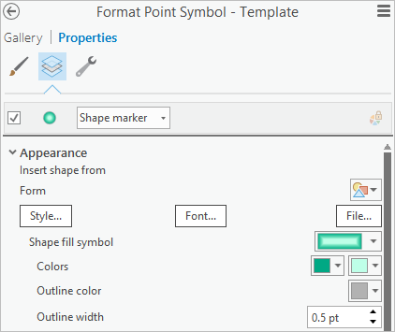

1. Click the Back button. Set the class breaks (Upper value) and labels to the following values:
   * For the smallest symbol, change Upper value to 99.0 and Label to Fewer than 100.
   * For the middle symbol, change Upper value to 200.0 and Label to 100 to 200.
   * For the largest symbol, change Upper value to 371.0 and Label to More than 200.

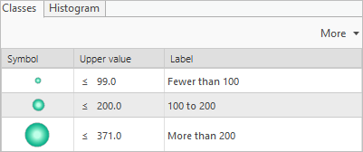

1. In the Contents pane, drag the County Outline layer to the top of the list of layers.

The map displays the gradient symbols.

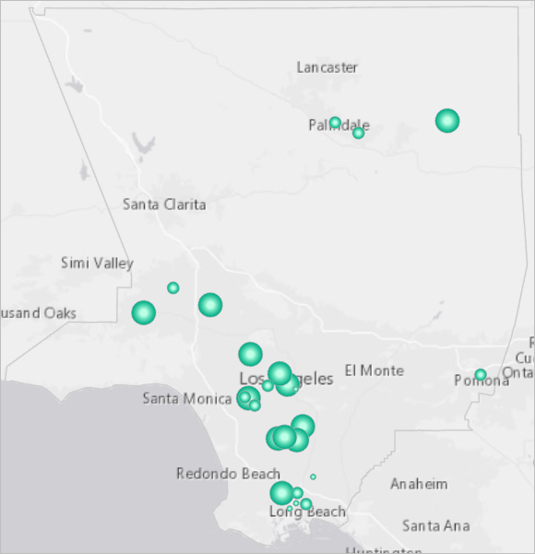

1. Follow the same process to display the ACS HHs/Gross Rent 50+ % of Income field in the Affordable_Housing_Project layer with similar symbols, changing only the following parameters:
   * For Colors, choose Dark Amethyst and Lepidolite Lilac.
   * For the smallest symbol, change Upper value to 599.0 and Label to Fewer than 600.
   * For the middle symbol, change Upper value to 800.0 and Label to 600 to 800.
   * For the largest symbol, change Upper value to 1023.0 and Label to More than 800.

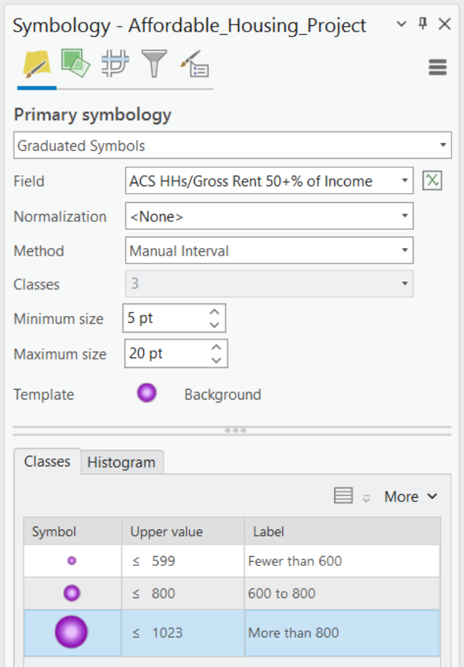

The symbology is applied to the map.

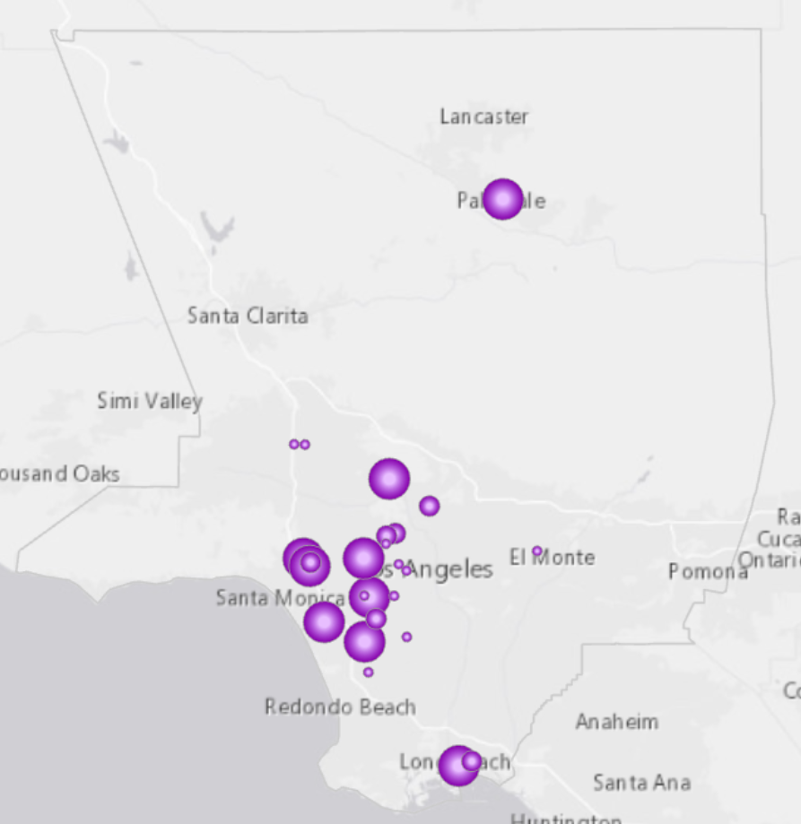

1. Close the Symbology pane. Save the project.

In this lesson, you identified targeted opportunities for preventing homelessness before it starts. The prevention programs you considered were for unemployment and the lack of affordable housing, but the same workflow could be used to identify priority locations for any risk factor.

In the next lesson, you'll use maps and charts to explore the characteristics of people who are already experiencing homelessness.

**Part 3. Map homeless communities**

In the previous lesson, you determined where targeted prevention programs would have the best chance of making a difference. In general, you were concerned with preventing homelessness before it starts. The remaining lessons focus on providing support and aid to people already experiencing homelessness.

In this lesson, you'll use maps and charts to reveal differences among homeless communities. You'll answer several questions: Who are the homeless? What are their needs? Where are they located?

**Step 1. Find concentrations of homeless people**

First, you'll perform hot spot analysis on data from the point-in-time count conducted in January 2017 for the Los Angeles Continuum of Care. The Continuum of Care region encompasses most of the county, but excludes the cities of Pasadena, Glendale, and Long Beach. Your analysis will pinpoint statistically significant concentrations of homeless people.

1. If necessary, open the Homelessness project in ArcGIS Pro.
2. Turn off all layers except the County Outline layer and the basemap.
3. Open the Geoprocessing pane. Search for and open the [Optimized Hot Spot Analysis](https://pro.arcgis.com/en/pro-app/tool-reference/spatial-statistics/optimized-hot-spot-analysis.htm) tool.
4. For Input Features, choose the Homeless Population Data layer. For Output Features, change the output name to Unsheltered_Density_Hot_Spots.

Large tracts often have more people (homeless or otherwise) because they cover large areas. If you were to analyze the number of unsheltered homeless people in each tract, the largest tracts would likely stand out. Rather than tract size, however, you're interested in understanding where unsheltered homeless people concentrate—where they cluster spatially. So instead of counts, you'll use a density variable calculated by dividing the number of unsheltered people in each tract by the tract's square area. Density values have already been calculated for you.

1. For the Analysis Field parameter, choose Unsheltered Homeless Pop Density.

The tool doesn't require a Distance Band value, but providing one ensures your hot spot maps are created using the same scale of analysis. This is important when you want to visually compare two or more hot spot maps.

1. Expand Override Settings. For the Distance Band parameter, enter 20000 US Survey Feet.

**Tip:** When you run the [Optimized Hot Spot Analysis](https://pro.arcgis.com/en/pro-app/tool-reference/spatial-statistics/optimized-hot-spot-analysis.htm) tool without a distance band, the tool examines the structure of your data and suggests an appropriate distance band. The value of 20,000 feet was obtained by rounding down the distance suggested by the tool when no distance band was given.

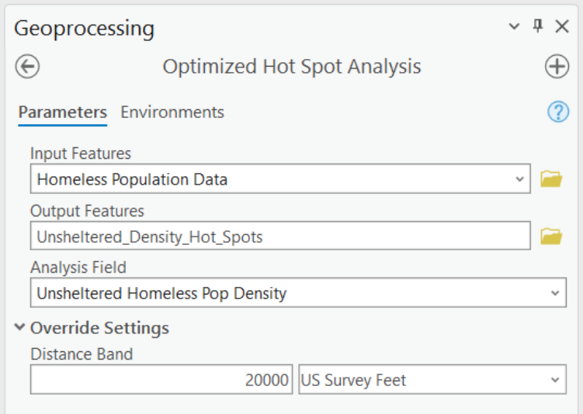

1. Click Run.

The tool runs and the output is added to the map. You'll improve the symbology by making the polygon outlines thinner.

1. In the Contents pane, right-click the Unsheltered_Density_Hot_Spots layer and choose Symbology.
2. Click More and choose Format all symbols.

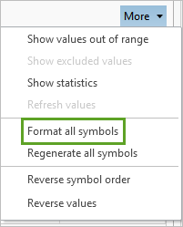

1. On the Properties tab, set Outline width to 0.2 and click Apply.
2. In the Contents pane, drag the County Outline layer above the hot spot layer.

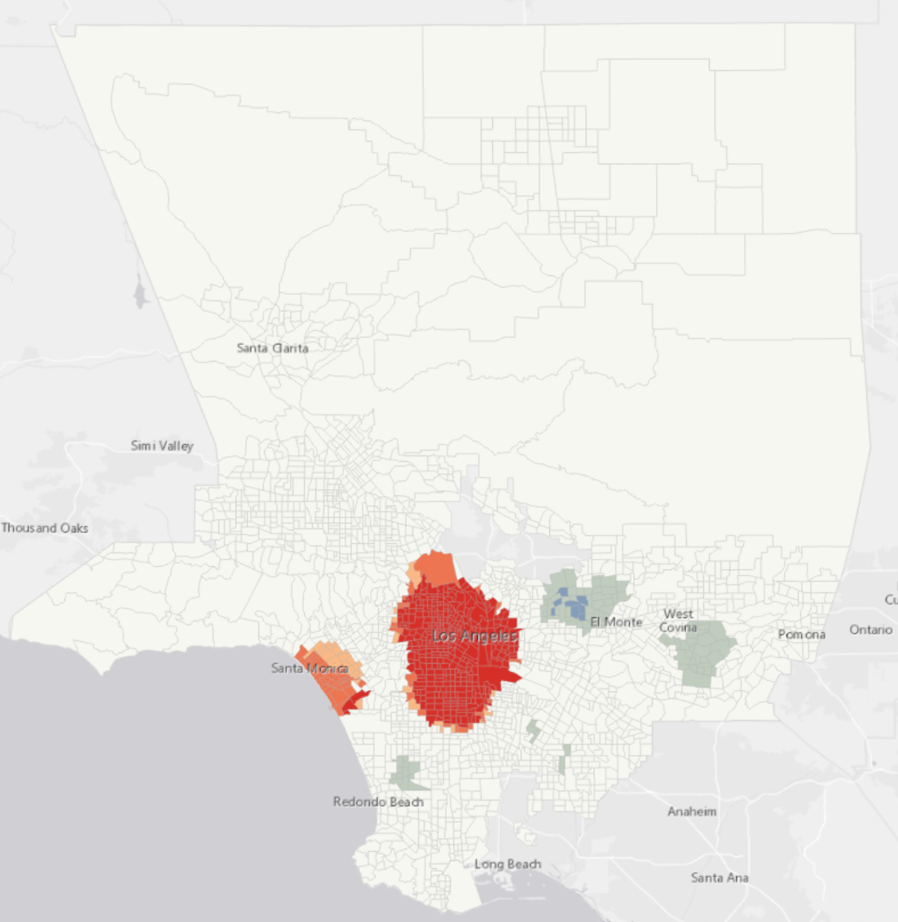

The red areas in and around downtown Los Angeles, including Skid Row, are statistically significant concentrations of unsheltered homeless people. The hot spot statistic used by the [Optimized Hot Spot Analysis](https://pro.arcgis.com/en/pro-app/tool-reference/spatial-statistics/optimized-hot-spot-analysis.htm) tool compares the actual distribution of high- and low-density values to a hypothetical random distribution. Red areas are locations where the spatial clustering of high densities deviates strongly and significantly from a random pattern. Similarly, the blue areas are locations where clustering of low densities is too intense to reflect a random pattern.

1. If necessary, reopen the [Optimized Hot Spot Analysis](https://pro.arcgis.com/en/pro-app/tool-reference/spatial-statistics/optimized-hot-spot-analysis.htm) tool.
2. For Output Features, type Sheletered_Density_Hot_Spots. For Analysis Field, choose Sheltered Homeless Pop Density.

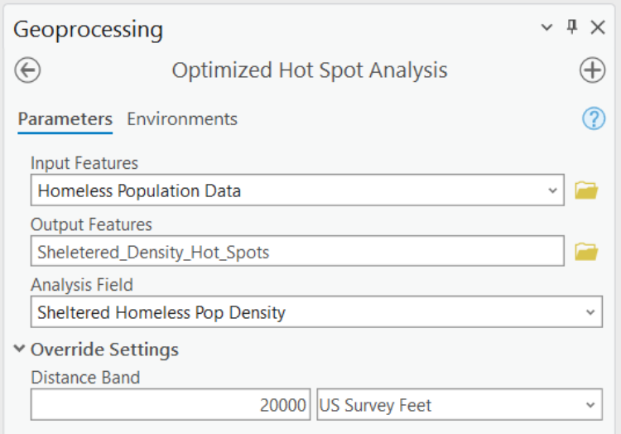

1. Click Run.

The tool runs and the output is added to the map. Both sheltered and unsheltered homeless densities are most concentrated in and around downtown Los Angeles.

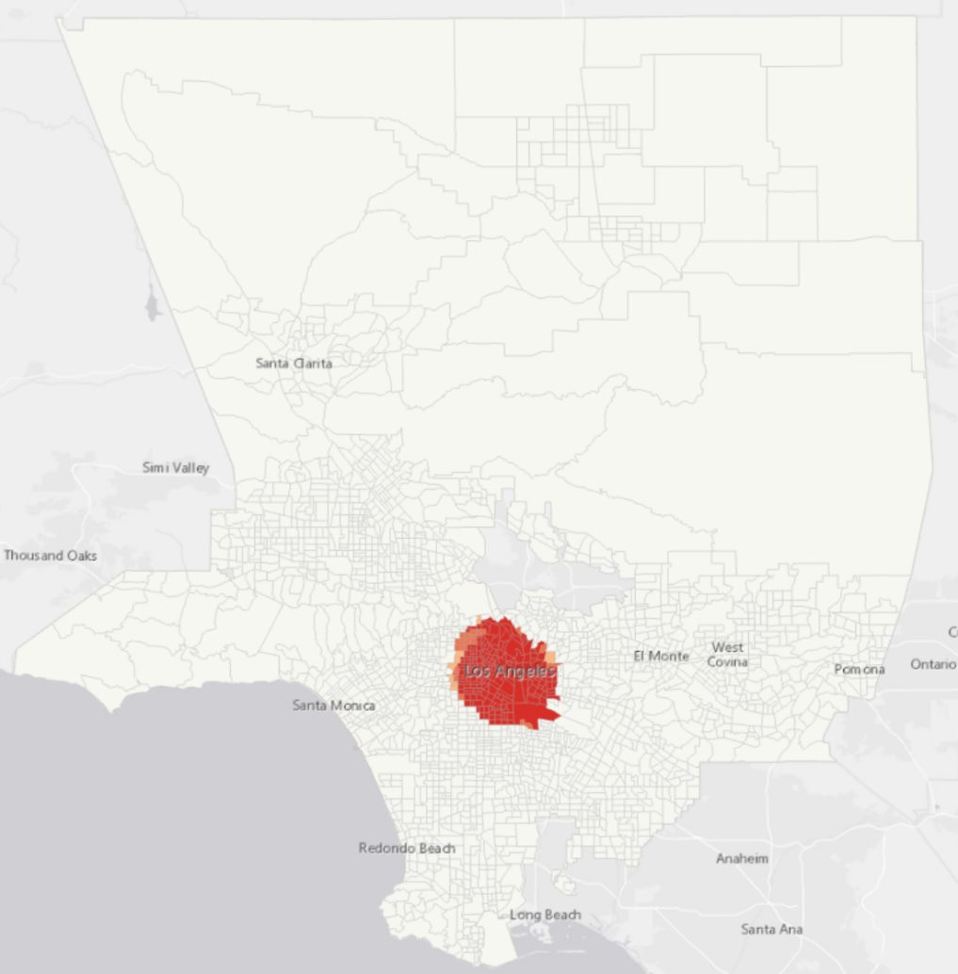

1. Save the project.

**Step 2. Chart homeless community characteristics**

Knowing where homeless people are concentrating is an important first step, but it must be followed by analyses to understand differences among homeless communities. Doing so leads to better decision making about the type of support and resources needed in each location.

The people experiencing homelessness in Venice Beach or Hollywood, for example, have different characteristics (and consequently different needs) than the people experiencing homelessness in Skid Row. While Skid Row has the smallest physical area, it contains the largest number of homeless people and 57 percent have access to emergency shelters, transitional housing, or safe havens. In Venice Beach, on the other hand, only 12 percent of the people experiencing homelessness have access to shelters. The risk factors contributing to homelessness are also different among homeless communities. You'll create charts to explore these differences.

1. Open the table for the Homeless Population Data layer.

The homeless characteristics data (risk factors, race/ethnicity, gender, and age) have been apportioned from Council District reports as well as from individual reports for Hollywood, Skid Row, and Venice Beach. Tracts outside the Council District areas don't have values (the values appear as Null). You'll select and then analyze the apportioned data.

1. In the Geoprocessing pane, search for and open the [Select Layer By Attribute](https://pro.arcgis.com/en/pro-app/tool-reference/data-management/select-layer-by-attribute.htm) tool. For Input Rows, choose Homeless Population Data. For Selection type, choose New selection.
2. Click New expression. Construct the clause Where Homeless Veterans is not null.
3. Click Add Clause. Construct the clause And Total Homeless People is greater than or equal to 10.

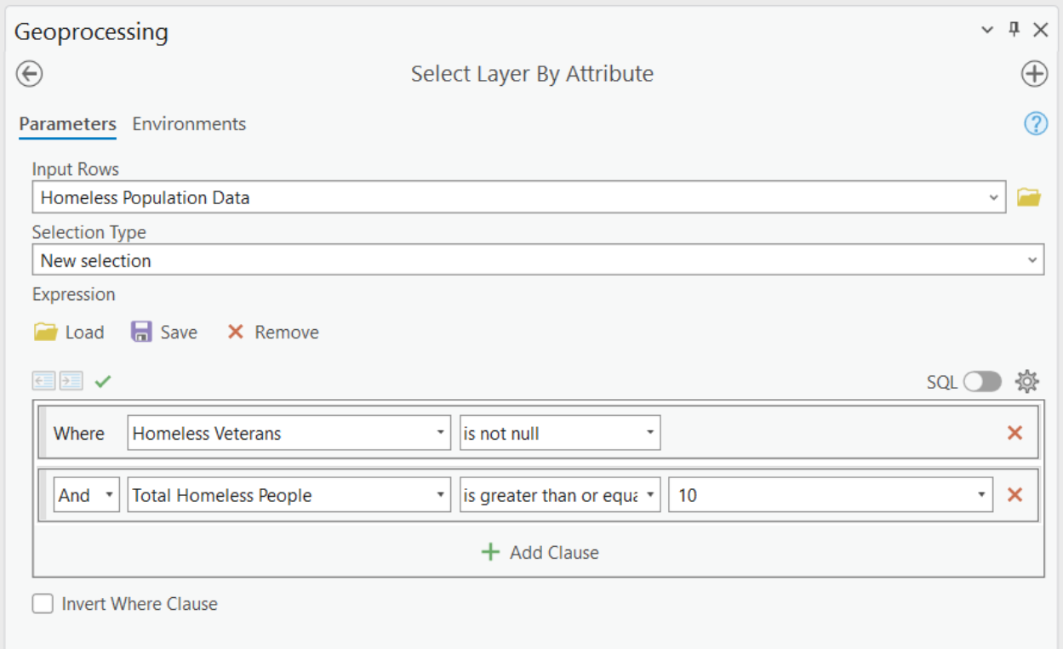

1. Click Run.

Census tracts that comply with the expressions are selected. You'll create a new feature class of the selected tracts.

1. Search for and open the [Copy Features](https://pro.arcgis.com/en/pro-app/tool-reference/data-management/copy-features.htm) tool. Enter the following parameters:
   * For Input Features, choose Homeless Population Data.
   * For Output Feature Class, type Homeless_Tapestry.
2. Click Run.

The tool runs and the new layer is added to Contents. The original layer still has selected features.

1. On the ribbon, on the Map tab, in the Selection group, click Clear.

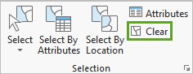

1. Close the table. Move the County Outline layer to the top of the Contents pane and turn off all layers except the Homeless_Tapestry, County Outline, and basemap layers.

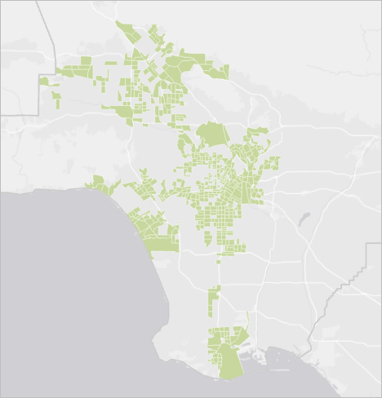

Next, you'll create charts to explore the unique characteristics of the homeless population across different communities.

1. Open the Symbology pane for the Homeless_Tapestry layer. Set the symbology using the following parameters:
   * For Primary symbology, choose Graduated Colors.
   * For Field, choose Total Homeless People.
   * For Method, choose Natural Breaks (Jenks).
   * For Classes, choose 5.
   * For Color scheme, choose the Red-Purple (Continuous) color ramp.

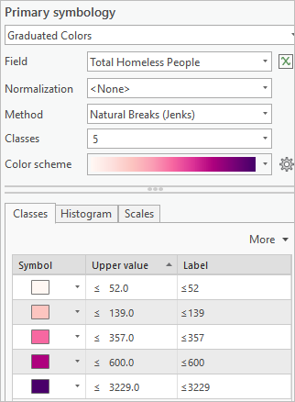

1. In the Contents pane, right-click the Homeless_Tapestry layer, point to Create Chart, and choose Scatter Plot.
2. Dock the empty chart window (Homeless_Tapestry - Scatter Plot) below the map.

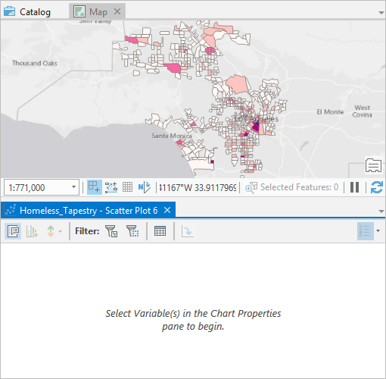

1. In the Chart Properties pane, on the Data tab, set the X-axis Number parameter to Homeless Veterans and the Y-axis Number to Chronically Homeless People.
2. Uncheck Show linear trend.

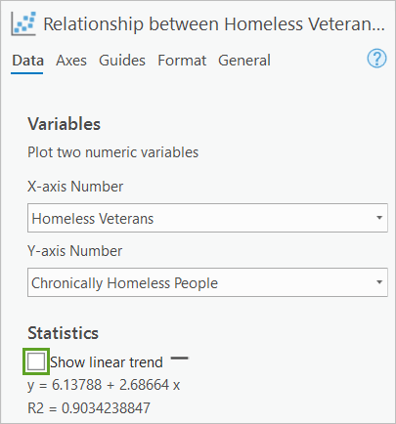

The trend line is most interesting when you want to look at correlations. In this case, you're using the scatterplot to explore variable values.

1. Click the General tab. Change Chart title to Homeless Veterans, Chronically Homeless People.

The chart updates automatically. Most of the data points are clustered in the lower left of the chart, with a few outliers in the upper right. This skew is common for many types of data. To improve the visualization of skewed data, you'll use a [log axis](https://pro.arcgis.com/en/pro-app/help/analysis/geoprocessing/charts/scatter-plot.htm#ESRI_SECTION1_EF233433425C44F181B4A834EFDD54EF).

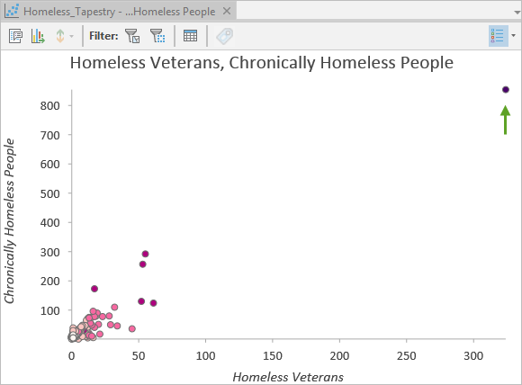

**Note:** On a logarithmic scale, increments increase by magnitudes. Logarithmic scales are useful when visualizing data with large positive skew, where the bulk of data points have a small value, and a few data points have very large values. Changing the scale of the axis doesn't change the value of the data, just the way the data values are displayed.

1. Click the Axes tab. Check Log axis for both the x-axis and the y-axis.

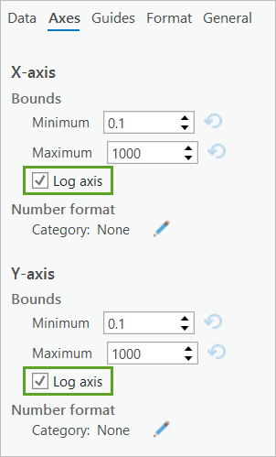

Now that you can better see the data points in your chart, you can begin to explore the characteristics of individual tracts through interactive selection.

1. On the chart, click the census tract with the highest number of homeless veterans and the highest number of chronically homeless people (the point in the upper right corner).

A selection is also made on the map, identifying the location of the census tract of interest. Additionally, the symbol color on the map, reflecting the total number of homeless people (the Total Homeless People field), matches the symbol color on the chart. Your map and chart are providing information about three different variables, plus location and value magnitude.

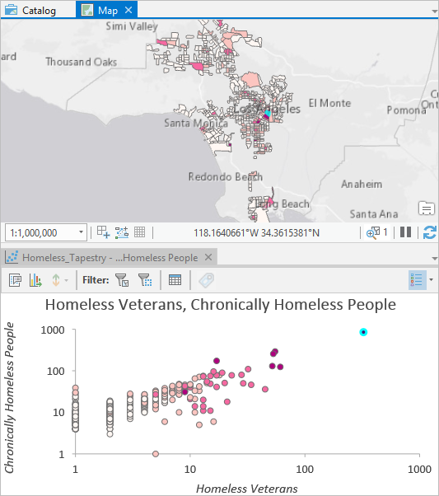

Ending homelessness among veterans is an important priority for Los Angeles. Moving chronically homeless individuals into permanent housing is an effective way to decrease overall homeless management costs. By providing aid and support to the people experiencing homelessness in the tract you identified, Los Angeles can address both of these objectives.

**Step 3. Explore homeless characteristics in more detail**

To explore the attributes of individual census tracts in more detail, you'll create additional charts that only show data for selected features. You'll begin by exploring different types of shelter options.

1. In the Contents pane, right-click the Homeless_Tapestry layer, point to Create Chart, and choose Bar Chart.
2. Dock the new chart window next to the map so both charts and the map are visible.

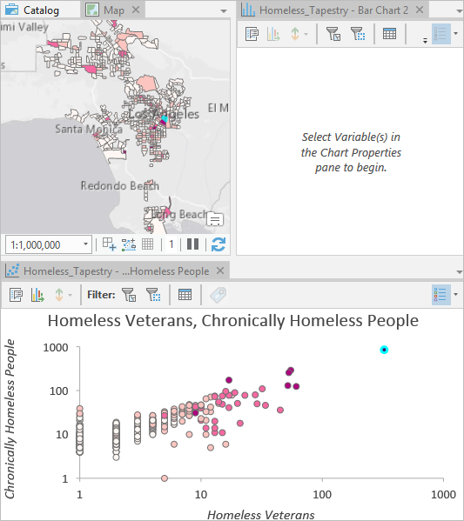

1. In the empty chart window, for Filter, click Selection.

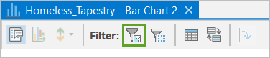

Now, only selected features appear in the chart.

1. In the Chart Properties pane, on the Data tab, for Category or Date, choose Community.
2. For Aggregation, choose Mean.
3. For the Numeric Field(s) parameter, choose the following fields:
   * % Cars, Vans, Campers
   * % Emergency Shelters, Transitional Housing, Safe Havens
   * % Street Homeless
   * % Tents, Encampments

These fields represent shelter types.

1. Click the Series tab. For the % Emergency Shelters, Transitional Housing, Safe Havens field, change the Label to % Shelters.

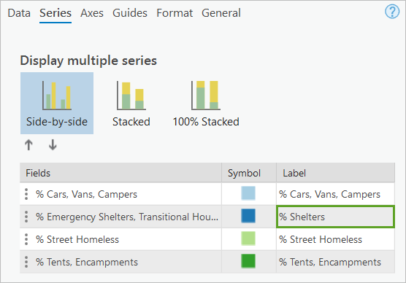

1. On the General tab, change Chart title to Shelter Type, and change Y axis title to % Homeless.
2. Select a few census tracts in different locations on the map, in the scatterplot, or in the table.

**Note:** To select census tracts on the map, click Select on the ribbon in the Selection group. Use the Shift key to add tracts to ones already selected.

The bar chart updates to show the shelter type breakdown sorted by community.

**Note:** Your chart may look different than the chart in the example.

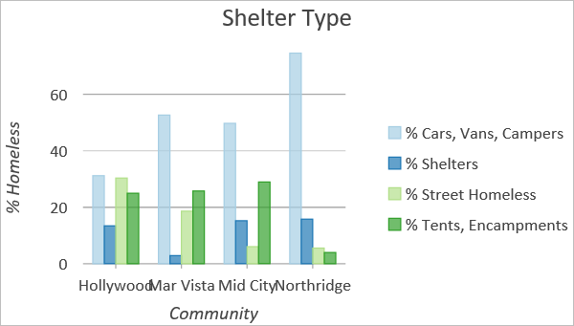

This chart allows you to investigate where people experiencing homelessness are finding shelter. This is important. For locations where many people are living in their vehicles, for example, implementing programs like [SafeParkingLA](https://www.safeparkingla.org/) may be effective. Preventing trash accumulation in locations with large numbers of homeless encampments is [important for preventing disease outbreaks](https://www.acsh.org/news/2018/10/06/homeless-update-typhus-outbreak-los-angeles-13483).

Next, you'll create another bar chart to explore different risk factors contributing to homelessness.

1. In the Contents pane, right-click the Homeless_Tapestry layer, point to Create Chart, and choose Bar Chart.
2. Dock the new chart window to the left of the scatterplot.
3. In the empty chart, click Filter by Selection.
4. In the Chart Properties pane, on the Data tab, change the following parameters:
   * For Category or Date, choose Community.
   * For Aggregation, choose Mean.
   * For Numeric Field(s), choose the following fields:
     + % Addicted
     + % Victims of Domestic Violence
     + % w Brain Injuries
     + % w Developmental Disabilities
     + % w HIV/AIDS
     + % w Physical Disabilities
     + % w Serious Mental Illness
5. Click Apply.
6. On the General tab, change Chart title to Risk Factors, and change Y axis title to % Homeless.
7. Select a few census tracts on the map, in the scatterplot, or in the table.

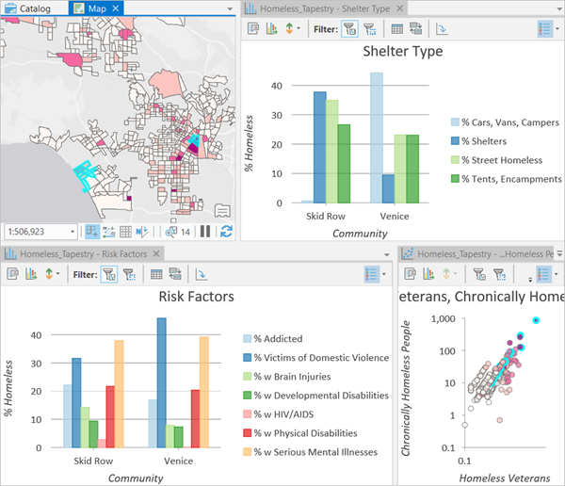

By understanding the primary factors contributing to homelessness tract by tract, Los Angeles can provide targeted support to the people experiencing homelessness.

**Step 4. Create a histogram**

Another way to explore the numeric fields in your data is to create a histogram. Histograms show how data values are distributed. You'll create a histogram to show the distribution of homeless children.

1. In the Contents pane, right-click the Homeless Tapestry layer, point to Create Chart, and choose Histogram.
2. Dock the newly opened chart window on top of the scatterplot.
3. In the Chart Properties pane, on the Data tab, set the following parameters:
   * For Number, choose % Under age 18.
   * For With transformation, choose Square Root.
   * For Number of bins, type 40.
   * Uncheck Mean.

The square root transformation improves visualization of skewed data.

1. On the Axes tab, click the edit button associated with the X-axis Numeric format.
2. Change Category to Numeric. Then change Decimal places to 2 and click Apply.

The y-axis (Count) is the number of census tracts associated with different percentages of homeless people under age 18.

1. On the General tab, change Chart title to Homeless Children. Change X axis title to % Under Age 18 (sq root).
2. Select the right tail of the histogram to highlight the census tracts with the highest percentage of homeless people under the age of 18.

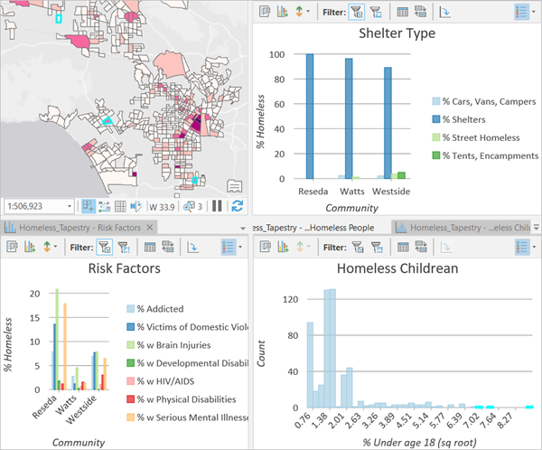

**Tip:** You can select individual bars in a bar chart using the Ctrl key or by dragging a box over consecutive bars.

You can explore other characteristics of the homeless population by changing the histogram variable. You'll do that next.

1. On the Data tab for the histogram, change Number to % Female.
2. Select the right tail of the histogram again and examine the location, shelter type, and risk factors for census tracts with the highest percentage of female homeless.

Your charts and maps identify locations where services for women and children, as well as runaway youth programs, are needed most.

Understanding differences among people experiencing homelessness from one location to another allows you to be more effective in meeting their needs and providing support. The analyses above focused on census tracts; next, you'll assess homeless characteristics and service needs by community.

**Step 5. Explore homeless characteristics by community**

To see results for all the tracts in individual communities, you'll create a bar chart to aggregate community census tracts.

1. In the Contents pane, right-click the Homeless Tapestry layer, point to Create Chart, and choose Bar Chart.
2. Dock the new chart over the histogram so all three bar charts and the map are visible.
3. In the Chart Properties pane, on the Data tab, set the following parameters.
   * For Category or Date, choose Community.
   * For Aggregation, choose Sum.
   * For Numeric Field(s), choose Total Homeless People.
4. On the General tab, change Chart title to Total Homeless by Community, and change Y axis title to Total Homeless People.
5. On the Data tab, click Sort and choose Y-axis Descending.
6. Select the two communities with the largest number of homeless people. Compare the associated shelter types and risk factors.

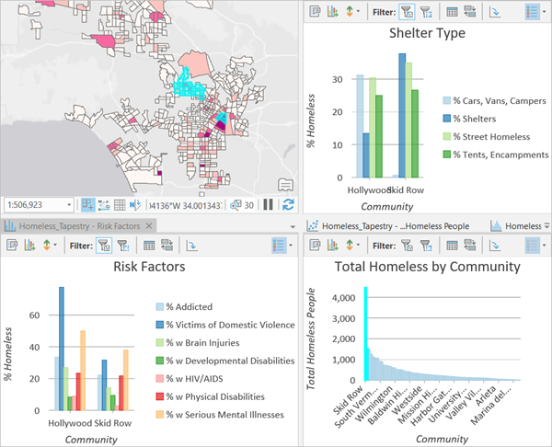

Skid Row has more than twice as many homeless people as Hollywood. The Shelter Type chart reveals that very few homeless people in Skid Row live in cars, vans, or campers. The Risk Factors chart indicates that a large percentage of homeless people in Hollywood are victims of domestic violence.

1. Close the charts, clear any active selections, and save the project.

In this lesson, you worked with [point-in-time count data](https://www.lahsa.org/homeless-count/) for the City of Los Angeles and Los Angeles County. Using maps and charts, you identified locations where people experiencing homelessness concentrate and explored variations in homeless community characteristics. You can use this same workflow with your own homeless census data.

If you have a good system in place to conduct your point-in-time homeless census, that's perfect. If you're looking for some resources to help you improve your survey, or if you need technology to help you collect the census data, consider the following suggestions:

* A key to prevention is understanding where people are becoming homeless. The point-in-time counts tell you where homeless people are, but you won't want to miss the opportunity to ask about last permanent residence (ZIP Code, address, or street intersection). The point-in-time counts are also an opportunity to ask about perceived reasons for homelessness to learn more about risk factors.
* Poor transitions from foster care, jail, and other institutions may be an important factor contributing to new homelessness. You can record if a person's last permanent housing was an institution and use this information to design appropriate remediation.
* Los Angeles County makes its [survey questions public](https://www.lahsa.org/news?article=410-2018-homeless-count-results). Looking at its survey may help you design or enhance your own survey questions.
* [A number of resources](https://www.arcgis.com/apps/MapJournal/index.html?appid=120547183c32429f896fbdc880ee8712) are available to help you learn about using Esri technology to conduct your own point-in-time homeless census. [The Survey123 for ArcGIS - Homeless Count video](https://www.youtube.com/watch?v=oRGTfRTUDVo&feature=youtu.be), in particular, explains the point-in-time count application.
* Los Angeles doesn't make the raw survey results public; only regional estimates are provided for many variables (age, risk factors, race/ethnicity, gender, veteran status, and so on). As a consequence, apportionment was applied to get tract-level estimates. You may notice many of the estimates are duplicated across tracts. This is because, apparently, the apportionment algorithm aligns with the original estimation method used. If you have raw survey results, however, you won't need to apportion the survey data but can instead use the survey results directly. The workflow outlined above will work fine.

In the next lesson, you'll consider where to invest in new resources to support and aid people experiencing homelessness. This is often a contentious issue. The workflow that follows encourages transparency and uses spatial overlay analysis to promote consensus.

**Part 4. Promote consensus**

In the previous lesson, you identified where people experiencing homelessness concentrate and explored the characteristics of different homeless communities. In this lesson, you'll answer the question: where are the best locations to invest in new resources to aid and support people experiencing homelessness?

Ask ten stakeholders and you'll likely get ten different ideas about where to invest in new resources. There is no one best solution. Mapping different planning scenario objectives, however, is an effective way to provide neutral ground for discussion, to encourage both transparency and collaboration, and to increase focused engagement.

You'll create several potential planning scenarios, each promoting a different objective. You'll then overlay all of the planning scenario maps to see if any locations optimize more than one objective.

**Step 1. Add resources to optimize social equity**

First, you'll create a map that shows where to add new resources if the goal is to optimize social equity. You'll compute a supply versus demand variable relating the total county population in each tract to the total homeless population in each tract.

1. If necessary, open the Homelessness project in ArcGIS Pro.
2. Turn off all layers except the County Outline layer, Additional Resources layer, and basemap.
3. In the Contents pane, drag the County Outline and Additional Resources layers to the top of the list of layers.

To compute the social equity index, you'll need the total number of residents and the total number of homeless people countywide. Later in the lesson, you'll need the total number of sheltered homeless countywide, so you'll also calculate that.

1. In the Geoprocessing pane, search for and open the [Summary Statistics](https://pro.arcgis.com/en/pro-app/tool-reference/analysis/summary-statistics.htm) tool.
2. For Input Table, choose Additional Resources. For Output Table, type Sum_Pop_Variables. Choose Sum for the 2017 Total Population, Total Homeless People, and Total Sheltered People fields.

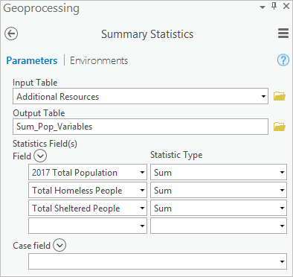

1. Click Run.

The tool runs. It writes the sum values for each field to the new output table.

1. In the Contents pane, right-click Sum_Pop_Variables and open the table.

The residential population is 9,446,500. The total homeless population is 49,703 (rounded up from 49,702.811; the floating-point number indicates some counts were estimated). The total sheltered homeless population is 12,933.

1. Close the table.

Next, you'll create a new field and calculate the social equity index.

1. Open and run the [Add Field](https://pro.arcgis.com/en/pro-app/tool-reference/data-management/add-field.htm) tool with the following parameters:
   * For Input Table, choose Additional Resources.
   * For Field Name, type SocialEquityIndex.
   * For Field Type, choose Float.
   * For Field Alias, type Social Equity Index.
2. Open and run the [Calculate Field](https://pro.arcgis.com/en/pro-app/tool-reference/data-management/calculate-field.htm) tool with the following parameters:
   * For Input Table, choose Additional Resources.
   * For Field Name, choose Social Equity Index.
   * For Expression, type (!TOTPOP_CY! / 9446500) - (!totPeople! / 49703).

**Note:** Tool expressions often use field names enclosed in exclamation marks rather than field aliases. The field name for the 2017 Total Population field is TOTPOP_CY; the field name for the Total Homeless People field is totPeople.

The first ratio in the expression (!TOTPOP_CY! / 9446500) reflects the portion of the county's residents in each census tract. The second ratio (!totPeople! / 49703) is the proportion of homeless people in each census tract. These two ratios are subtracted. If the ratios are equal (a tract has 2 percent of the county's residents and 2 percent of the county's homeless), the difference is zero, representing perfect equity. If the difference is positive (a tract has 4 percent of the county's residents and 2 percent of the county's homeless population), there is a higher proportion of residents than homeless people. These tracts aren't caring for their share of the homeless population. Adding new resources to these tracts should alleviate the imbalance. A negative difference means the proportion of homeless people is larger than the proportion of residents. These tracts are caring for more than their share of the homeless population.

1. Open the Symbology pane for the Additional Resources layer. Symbolize the layer using the following parameters:
   * For Primary symbology, choose Graduated Colors.
   * For Field, choose Social Equity Index.
   * For Method, choose Standard Deviation.
   * Click More and choose Reverse values.

**Note:** If you don't see the Social Equity Index field as an option for the Field parameter, change Primary symbology to Unique Values. Then change it back to Graduated Colors to refresh the field list.

Reversing the symbol order and values puts the class you want to focus on at the top of the legend. The positive deviations from the mean reflect tracts where new resources should be added.

1. For the 0.50 - 0.84 Std. Dev. class break, right-click the symbol and choose Peony Pink (a bright color). Choose progressively darker gray colors (Arctic White, Gray 10%, Gray 30%, and Gray 50%) for the remaining class breaks.

**Tip:** Always use a neutral color for the -0.50 - 0.50 Std. Dev. class break because it represents the mean (what's expected and, consequently, not most interesting).

1. Click More and choose Format all symbols.
2. On the Properties tab, change Outline width to 0.25 and change Outline color to Gray 10%. Click Apply.
3. On the Primary Symbology pane, change the labels to the following values:
   * For the first symbol, change the label to Add new resources here to promote equity.
   * For the second symbol, change the label to Equity.
   * For the third symbol, change the label to Bearing more than their share.
   * For the fourth symbol, change the label to Bearing much more than their share.
   * For the fifth symbol, change the label to Bearing the largest burden of homelessness.

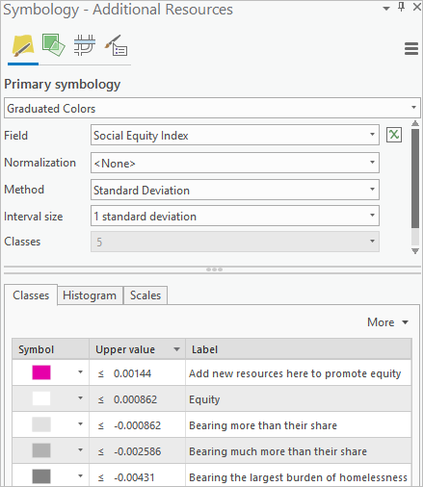

The symbology updates on the map.

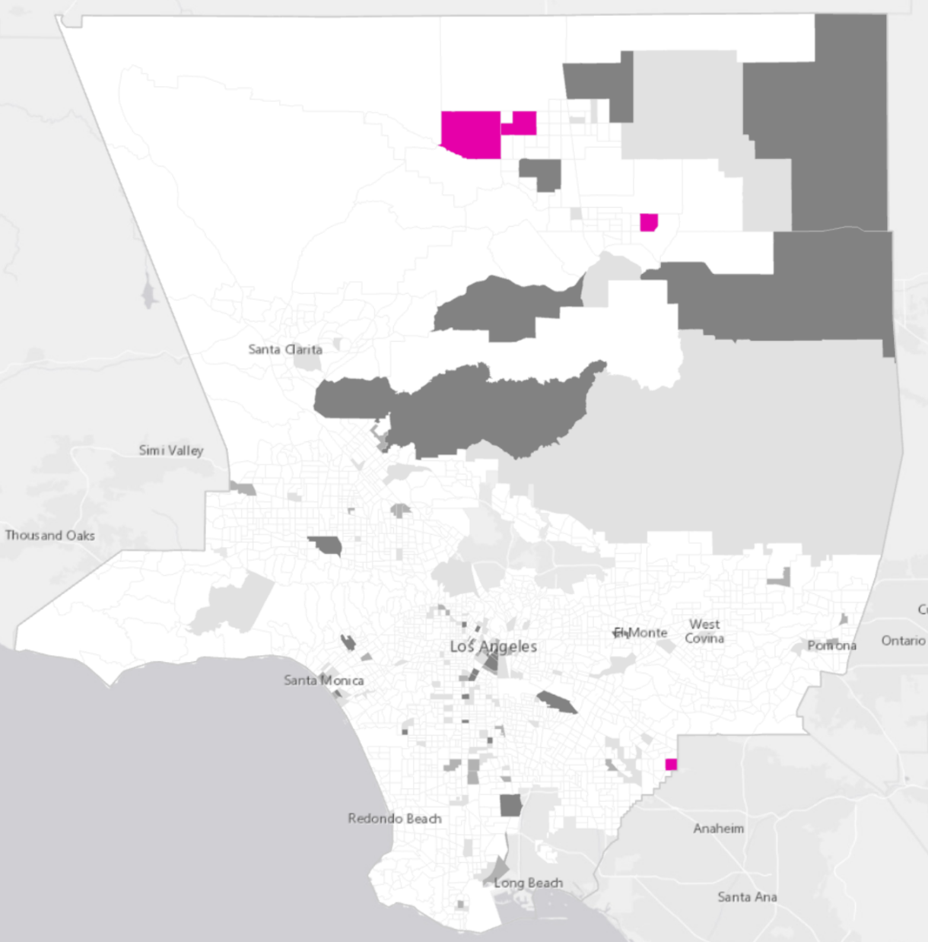

The tracts where new resources will promote social equity have index values larger than 0.000862. To flag these tracts, you'll create a new field that has two possible values, 0 and 1. You'll give tracts with an index less than 0.000862 a value of 0 and tracts with a higher index a value of 1. You'll sum the flag fields at the end of this lesson to identify locations that optimize multiple planning scenario objectives.

1. Open and run the [Add Field](https://pro.arcgis.com/en/pro-app/tool-reference/data-management/add-field.htm) tool with the following parameters:
   * For Input Table, choose Additional Resources.
   * For Field Name, choose SocialEquityFlag.
   * For Field Type, choose Short.
2. Open and run the [Calculate Field](https://pro.arcgis.com/en/pro-app/tool-reference/data-management/calculate-field.htm) tool with the following parameters:
   * For Input Table, choose Additional Resources.
   * For Field Name, choose SocialEquityFlag.
   * For Expression, type 0.
3. Open and run the [Select Layer By Attribute](https://pro.arcgis.com/en/pro-app/tool-reference/data-management/select-layer-by-attribute.htm) tool with the following parameters:
   * For Input Rows, choose Additional Resources.
   * For Selection type, choose New selection.
   * For Expression, create the expression Where Social Equity Index is greater than 0.000862.

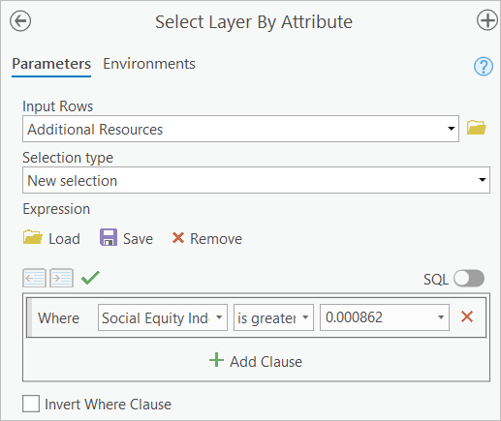

Four tracts are selected.

1. Open and run the [Calculate Field](https://pro.arcgis.com/en/pro-app/tool-reference/data-management/calculate-field.htm) tool with the following parameters:
   * For Input Table, choose Additional Resources.
   * For Field Name, choose SocialEquityFlag.
   * For Expression, type 1.

For the selected records, the value of the SocialEquityFlag field is set to 1.

1. Clear the selection.

You'll save your symbology for the Social Equity Index field to a file you can view later. Later, you'll override the existing symbology.

1. Right-click the Additional Resources layer and choose Sharing.
2. Choose Save as Layer File and specify a folder. Name the file SocialEquityMap.lyrx.
3. Save the project.

**Step 2. Add resources to prioritize accessibility**

A second possible planning scenario for locating new resources is to add them so they prioritize accessibility for existing homeless people. For this option, you'll compute another supply versus demand variable, but you'll base it on the relationship between the existing homeless population and existing homeless resources. Because Los Angeles doesn't yet provide complete data about homeless resources, you'll use the number of sheltered homeless people as a surrogate for all homeless resources.

You'll add a new field, calculate the accessibility index, and create a map.

1. Add a new field to the Additional Resources layer named AccessibilityIndex of type Float. For Field Alias, type Accessibility Index.

**Note:** If you have trouble adding a field, review the step to add a field in the previous section.

1. Calculate the values for the Accessibility Index field using the following parameters:
   * For Input Table, choose Additional Resources.
   * For Field Name, choose Accessibility Index.
   * For the Expression, type (!totPeople! / 49703) - (!totSheltPeople! / 12933).

**Note:** If you have trouble calculating a field, review the step to calculate a field in the previous section.

The first ratio in the Expression (!totPeople! / 49703) is the proportion of all homeless people in a tract. The second ratio is the proportion of all sheltered homeless people in a tract. Perfect accessibility is exhibited in tracts where the proportion of homeless people matches the proportion of sheltered homeless people. In Los Angeles, there is a large deficit of shelter opportunities and the formula takes this into account. A tract with 2 percent of the county's homeless people should have 2 percent of the county's available shelter opportunities. That is, the deficit should be justly distributed across the county.

The ratios are subtracted, so if they match, the difference is zero. This difference represents an optimal distribution of existing shelters. If the difference is positive, the proportion of homeless people is larger than the proportion of sheltered homeless people, indicating poor access to shelter opportunities. If the difference is negative, the proportion of shelter opportunities is larger than the proportion of homeless people, indicating better than average access to shelter opportunities.

You'll symbolize the Accessibility Index field the same way you symbolized the Social Equity Index field.

1. Symbolize the Accessibility Index values using the following parameters:
   * For Primary symbology, choose Graduated Colors.
   * For Field, choose Accessibility Index.
   * For Method, choose Standard Deviation.
2. Use three bright colors (Peony Pink, Fuchsia Pink, and Rhodolite Rose) for the class breaks with positive deviations from the mean. Use a neutral color (Arctic White) to symbolize the -0.50 - 0.50 Std. Dev. class break. For the class breaks with negative deviations from the mean, use progressively darker gray colors (Gray 10%, Gray 30%, and Gray 50%).
3. Click More and choose Format all symbols.
4. On the Properties tab, change Outline width to 0.25. Change Outline color to Gray 10%.
5. Change the following labels:
   * For the first symbol, change the label to Add new resources here to improve accessibility.
   * For the fourth symbol, change the label to Balanced.
   * For the seventh symbol, change the label to Best access to existing resources.
   * Remove all other labels.

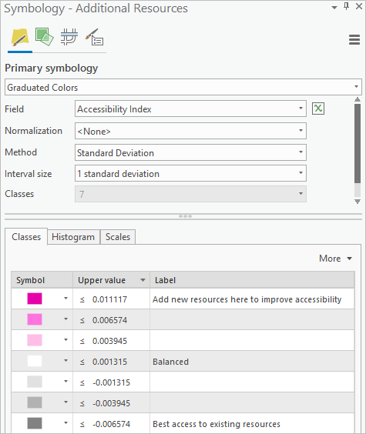

The map updates with the new symbology.

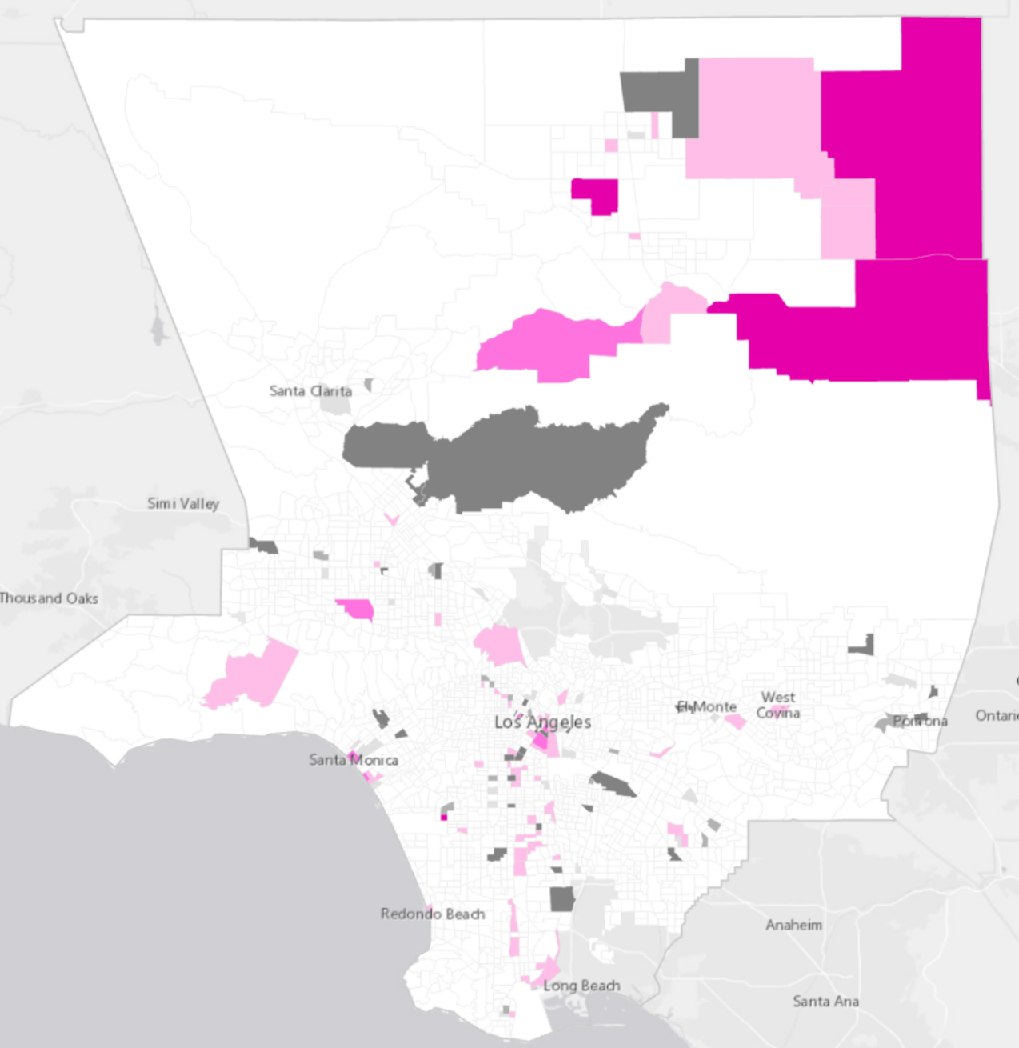

The tracts with accessibility indices greater than 0.001315 are good candidates for new resources if the goal is to improve accessibility. You'll create a field to flag these tracts.

1. Add a field to the Additional Resources layer named AccessibilityFlag with a Field Type of Short.
2. Calculate the AccessibilityFlag field so all values are zero.
3. Open and run the [Select Layer By Attribute](https://pro.arcgis.com/en/pro-app/tool-reference/data-management/select-layer-by-attribute.htm) tool to select tracts with an Accessibility Index greater than 0.001315.
4. For the selected records, set the AccessibilityFlag values to 1.
5. Clear the selection.
6. In the Contents pane, right-click the Additional Resources layer, point to Sharing, and choose Save as Layer File. Browse to a folder of your choice and save the file with the name AccessibilityMap.lyrx.
7. Save the project.

**Step 3. Add resources to assist the newly homeless**

A third possible planning scenario is to focus on areas at highest risk for generating new homelessness. If resources are available where they become homeless, people are more likely to remain in or near their own communities, where they likely have a broader set of personal and social resources. Providing new resources in high-risk areas is the [strategy being promoted by the mayor of New York](https://www1.nyc.gov/office-of-the-mayor/news/118-17/de-blasio-administration-plan-turn-tide-homelessness-borough-based#/0).

You'll use the Risk_Surface layer you created in the first lesson to indicate how likely a tract is to generate new homelessness.

1. Add a new field using the following parameters:
   * For Input Table, choose Additional Resources.
   * For Field Name, type RiskIdx.
   * For Field Type, choose Float.
   * For Field Alias, type Risk Index.

You'll link the records in the Risk_Surface layer with records in the Additional Resources layer.

1. Open and run the [Add Join](https://pro.arcgis.com/en/pro-app/tool-reference/data-management/add-join.htm) tool with the following parameters:
   * For Layer Name or Table View, choose Additional Resources.
   * For Input Join Field, choose UniqID.
   * For Join Table, choose Risk_Surface.
   * For Output Join Field, choose CAND_ID.
   * Confirm that Keep All Target Features is checked.

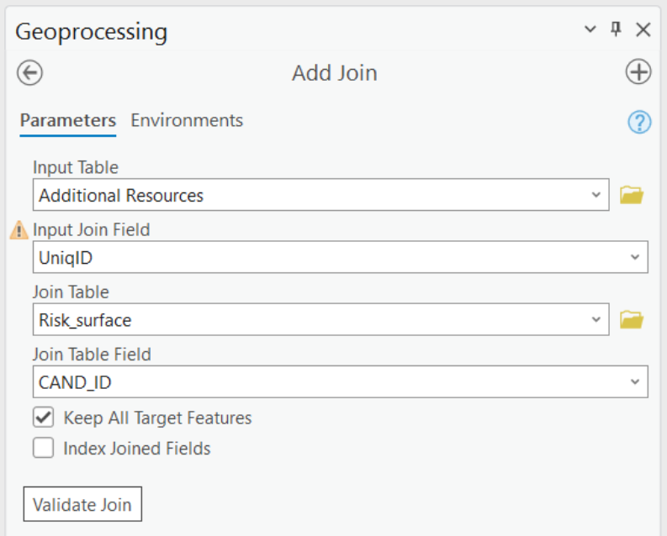

**Note:** If you point to the warning symbol next to the Input Join Field parameter, a message explains that the Additional Resources layer isn't indexed. This could impact performance. In this case, however, the tool completes in a few seconds, so performance isn't an issue. Creating an index isn't necessary.

You'll transfer the risk rankings from the Risk_Surface layer to the Additional Resources layer. The Render Rank (LABELRANK) field has rankings that range from 1 (highest risk) to 2,343 (lowest risk). To be consistent with the other indices you've been using, you'll reverse the rankings so that the largest rank reflects the highest risk.

1. Open and run the [Calculate Field](https://pro.arcgis.com/en/pro-app/tool-reference/data-management/calculate-field.htm) tool with the following parameters:
   * For Input Table, choose Additional Resources.
   * For Field Name, choose Additional_Resources.RiskIdx.
   * For Expression, type 2344 - !Risk_Surface.LABELRANK!.

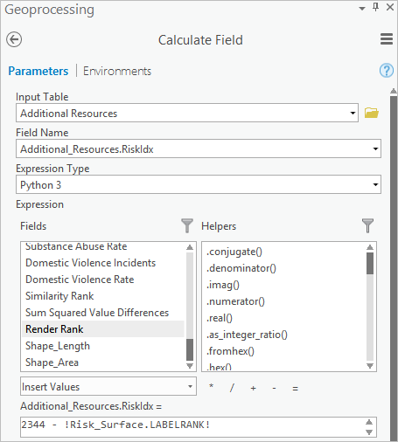

Each field identifies its source layer. Next, you'll unlink the joined layers.

1. Run the [Remove Join](https://pro.arcgis.com/en/pro-app/tool-reference/data-management/remove-join.htm) tool with the following parameters:
   * For Layer Name or Table View, choose Additional Resources.
   * For Join, choose Risk_Surface.

Next, you'll symbolize the layer by the Risk Index field. Since risk isn't a diverging attribute, it's appropriate to use graduated colors.

1. Symbolize the Additional Resources layer with the following parameters:
   * For Primary symbology, choose Graduated Colors.
   * For Field, choose Risk Index.
   * For Method, choose Standard Deviation.
   * Change the first symbol to Cattleya Orchid, the second symbol to Fuchsia Pink, the third symbol to Rhodolite Rose, and the fourth and fifth symbols to Arctic White.
   * Change the first label to Highest risk for new homelessness, the third label to Medium risk for new homelessness, and the fifth label to Lowest risk for new homelessness. Remove the other labels.

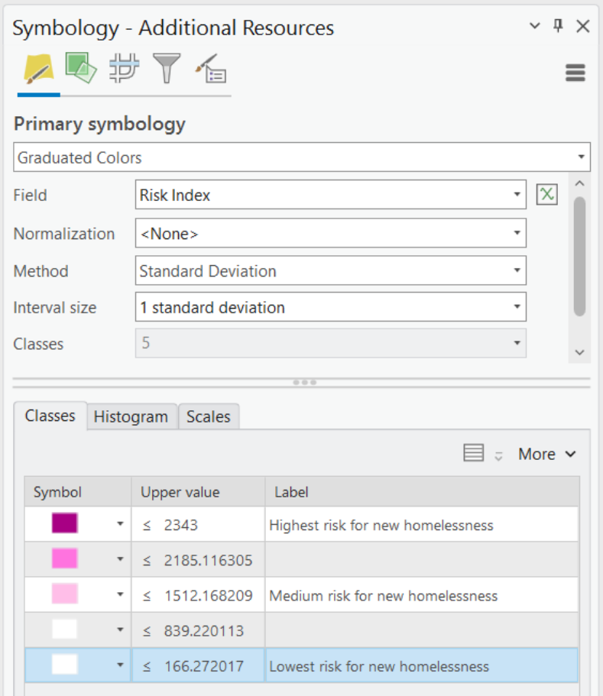

1. Format all symbols to have 0.25 point pale gray (Gray 10%) outlines.

The map updates with the new symbology.

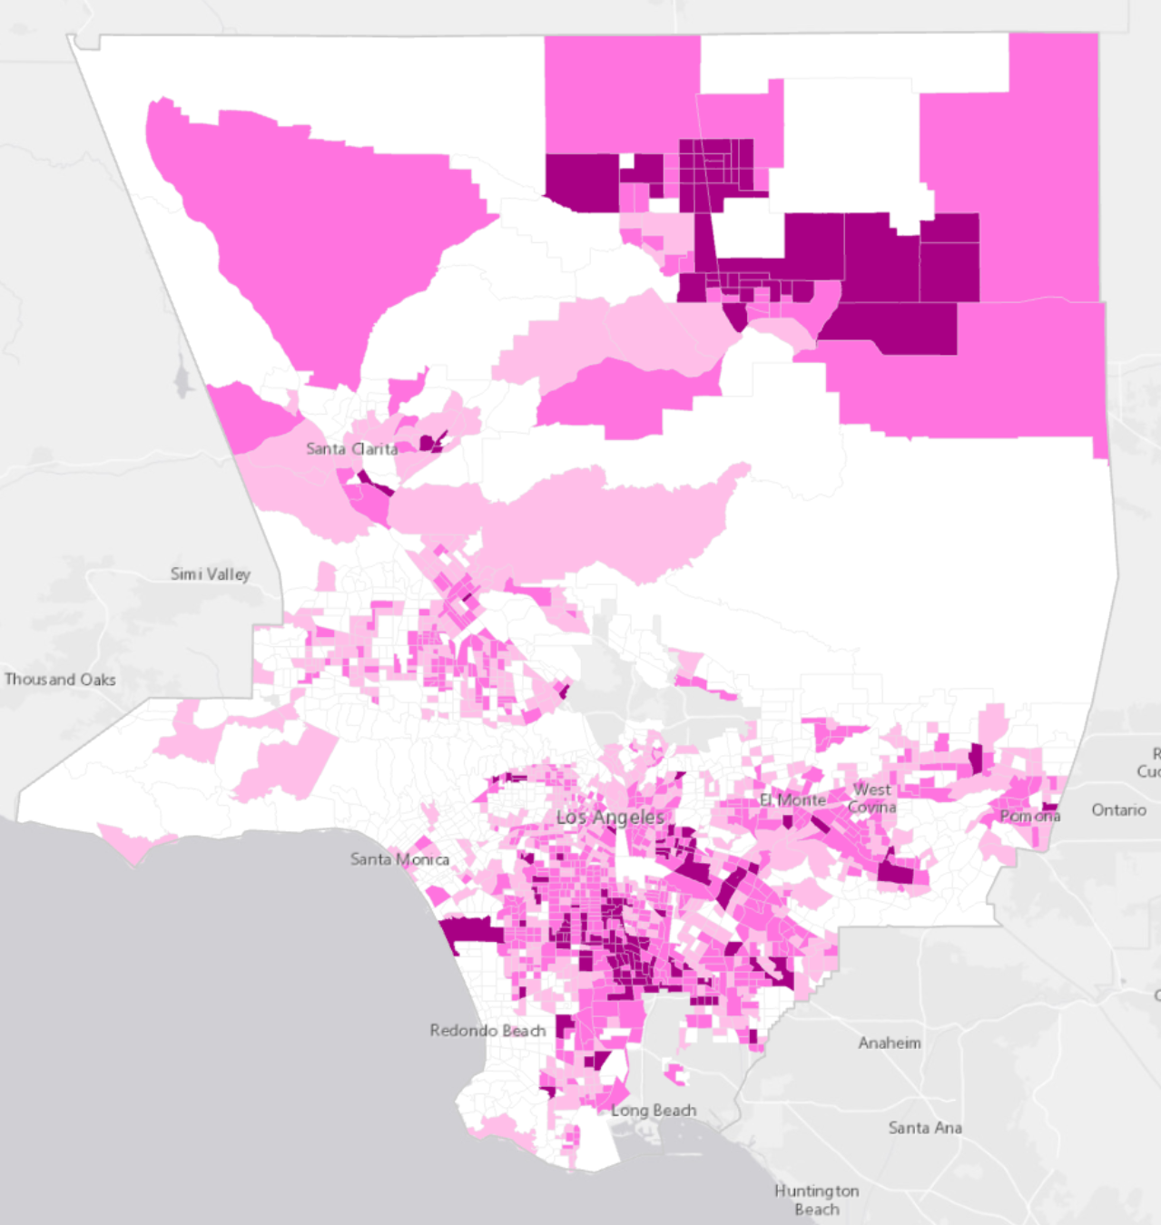

The tracts with risk indices greater than 1,513 are good candidates for investment if the goal is to provide new resources where people are at highest risk for becoming homeless.

1. Add a field to the Additional Resources layer named RiskFlag with a Field Type of Short. Run the [Calculate Field](https://pro.arcgis.com/en/pro-app/tool-reference/data-management/calculate-field.htm) tool to make all values for the new field zero.
2. Run the [Select Layer By Attribute](https://pro.arcgis.com/en/pro-app/tool-reference/data-management/select-layer-by-attribute.htm) tool to select tracts with a Risk Index greater than 1,513. Run the [Calculate Field](https://pro.arcgis.com/en/pro-app/tool-reference/data-management/calculate-field.htm) tool to set the RiskFlag to 1 for the selected tracts.
3. Clear the selection. In the Contents pane, right-click the Additional Resources layer, point to Sharing, and choose Save as Layer File. Save the file with the name RiskMap.lyrx.
4. Save the project.

**Step 4. Centralize homeless resources**

A fourth possible planning scenario is to consolidate new resources into triage centers by encouraging centralization. This creates resource hubs and is [the model](http://hsh.sfgov.org/services/emergencyshelter/navigation-centers/) San Francisco has adopted. For this planning scenario, you'll use the total number of sheltered homeless people as a surrogate for existing homeless resources.

1. Open the Symbology pane for the Additional Resources layer. Symbolize the layer using the following parameters:
   * For Primary symbology, choose Graduated Colors.
   * For Field, choose Total Sheltered People.
   * For Method, choose Standard Deviation.
   * Change the first symbol to Cattleya Orchid, the second symbol to Fuchsia Pink, the third symbol to Rhodolite Rose, and the fourth symbol to Arctic White.
   * Change the first label to Highest priority, the second label to Medium priority, the third label to Low priority, and the fourth label to Lowest priority.

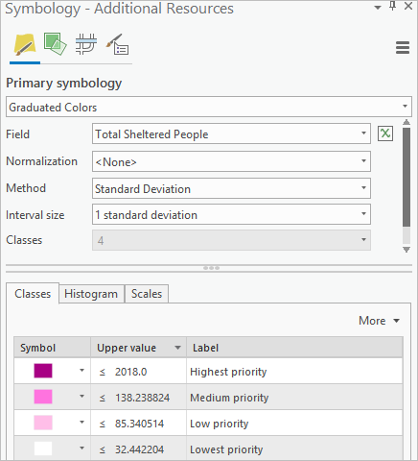

1. Format all symbols to have 0.25 point pale gray (Gray 10%) outlines.

The map updates to show the new symbology.

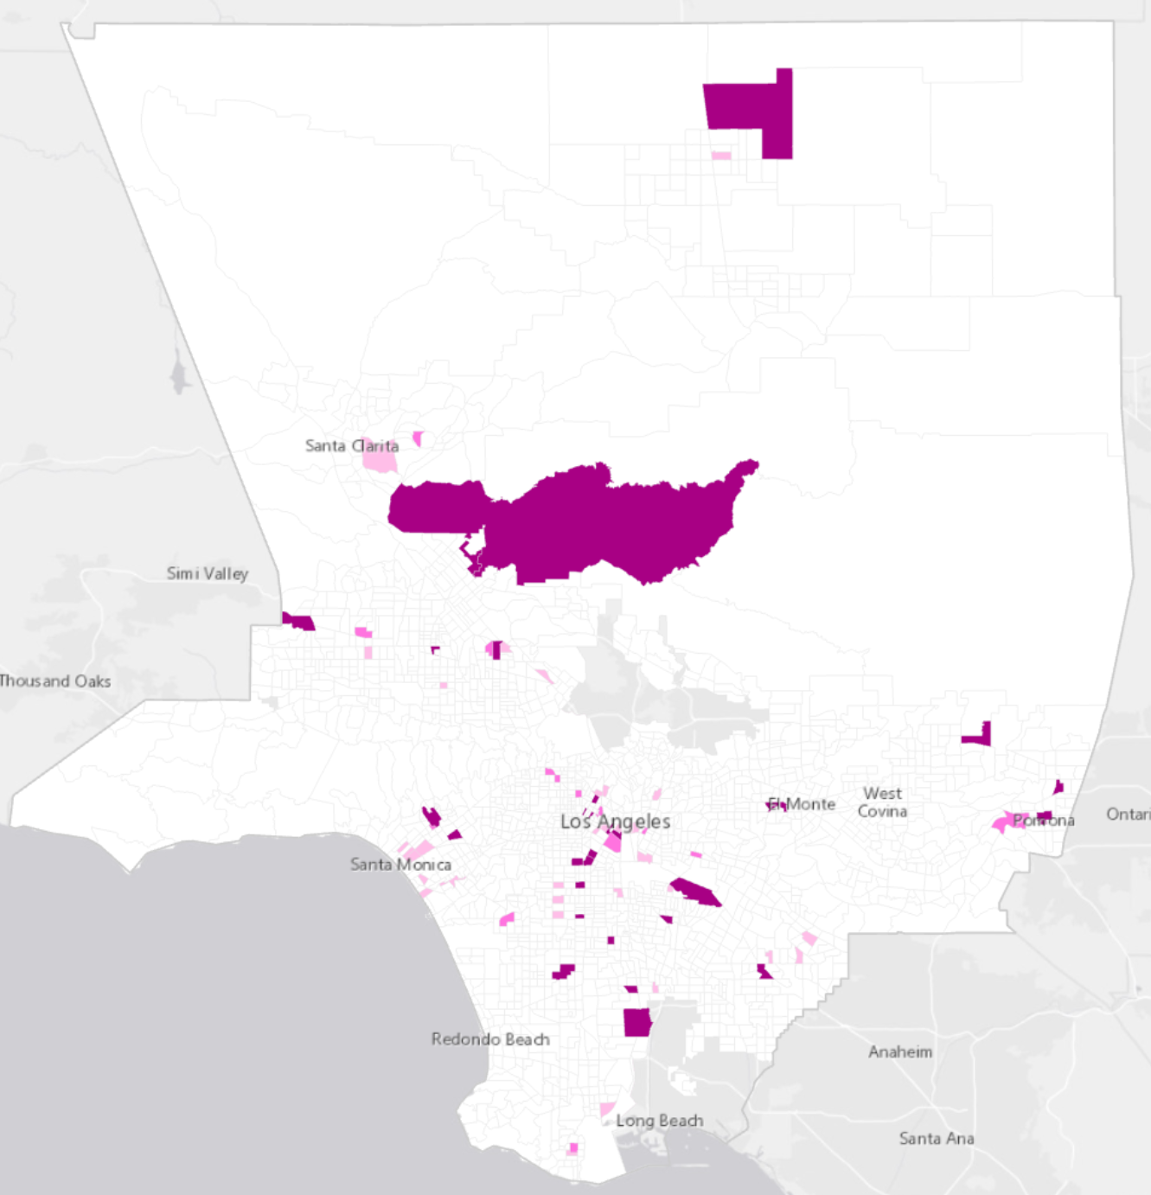

The tracts with resource counts larger than 85 are good candidates for new resources if the goal is to promote centralization of resources into navigation hubs.

1. Add a field to the Additional Resources layer named CentralizationFlag with a Field Type of Short. Calculate the new field's values to be zero.
2. Run the [Select Layer By Attribute](https://pro.arcgis.com/en/pro-app/tool-reference/data-management/select-layer-by-attribute.htm) tool to select tracts where the value for Total Sheltered People is greater than 85. Set the CentralizationFlag to 1 for the selected tracts.
3. Clear the selection. In the Contents pane, right-click the Additional Resources layer, point to Sharing, and choose Save as Layer File. Save the file with the name CentralizationMap.lyrx.
4. Save the project.

**Step 5. Focus on the most vulnerable homeless populations**

Another option is a street strategy that identifies the most vulnerable homeless populations, evidenced by 311 calls, crime incidents involving homeless people, and a large number of chronically homeless individuals. These locations become candidates for rapid-response, focused interventions aimed at providing every homeless person with precisely what they need to move out of homelessness permanently. [Some research papers](https://economicrt.org/publication/prioritizing-which-homeless-people-get-housing-using-predictive-algorithms/) conclude that a small portion of the homeless population (primarily the chronically homeless street population) use a majority of the money targeted for homelessness.

**Note:** 311 is a phone hotline number that United States citizens can use to receive local resource information or to report a problem in their community. This analysis uses the number of calls relating to homeless people or homeless encampments.

The data needed for this analysis isn't available for all tracts in Los Angeles. You'll create the planning scenario map for tracts where data is available. Similar to the workflow for creating a risk surface, you'll create a street strategy target tract with worst-case values and use the [Similarity Search](https://pro.arcgis.com/en/pro-app/tool-reference/spatial-statistics/similarity-search.htm) tool to rank all other tracts in relation to that target. Finally, you'll symbolize the result layer and create a flag variable, like you've done for each of the other planning scenarios.

1. Turn off the County Outline layer and select any tract to serve as the street strategy target tract.

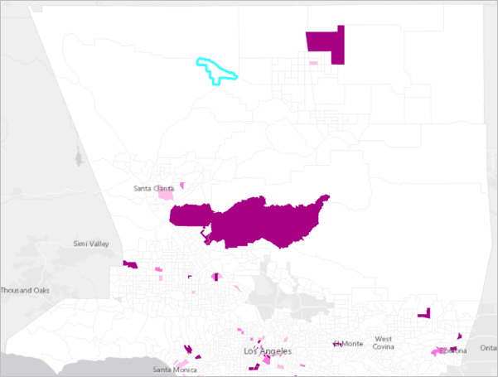

1. Run the [Copy Features](https://pro.arcgis.com/en/pro-app/tool-reference/data-management/copy-features.htm) tool using the following parameters:
   * For Input Features, choose Additional Resources.
   * For Output Feature Class, type SS_Target_Tract.

The copied layer, showing only the selected tract, is added to the map.

1. Turn off the Additional Resources layer.
2. Use the Select tool to select the copied census tract.
3. On the ribbon, click the Edit tab. In the Tools group, click Move.
4. Drag the selected census tract outside of Los Angeles County.
5. At the bottom of the map, click Finish.
6. On the ribbon, in the Manage Edits group, click Save and confirm that you want to save all edits when the prompt appears.
7. Clear the selection. Turn on the County Outline and Additional Resources layers.
8. Edit the SS_Target_Tract field values for Victim Count, 311 Call Count, and Chronically Homeless so they reflect the worst (largest) values in the Additional Resources study area.

**Note:** To find the largest values, sort the listed fields from largest to smallest. The largest value for Victim Count is 332. The largest value for 311 Call Count is 330. The largest value for Chronically Homeless is 854.

1. On the ribbon, on the Edit tab, in the Manage Edits group, click Save. Confirm that you want to save all of your edits when the prompt appears.

You'll rank all tracks that have these data fields, from worst to best.

1. Search for and open the [Similarity Search](https://pro.arcgis.com/en/pro-app/tool-reference/spatial-statistics/similarity-search.htm) tool.
2. Run the tool with the following parameters:
   * For Input Features To Match, choose SS_Target_Tract.
   * For Candidate Features, choose Additional Resources.
   * For Output Features, type Street_Strategy_Rankings.
   * For Number Of Results, type 0.
   * For Attributes Of Interest, choose VictimCount, 311 Call Count, and Chronically Homeless.

**Note:** You may receive a warning about problems reading some records. This is expected because the attribute values are null for tracts where data isn't available. You can ignore the warnings.

Next, you'll use the Render Rank field in the output layer to create a street strategy index field.

1. Turn off the Additional Resources and SS_Target_Tract layers.
2. Add a new field to hold the street strategy index values using the following parameters:
   * For Input Table, choose Additional Resources.
   * For Field Name, type SSIndex.
   * For Field Type, choose Float.
   * For Field Alias, type Street Strategy Index.

You'll join the output from the Similarity Search tool to the Additional Resources layer.

1. Run the [Add Join](https://pro.arcgis.com/en/pro-app/tool-reference/data-management/add-join.htm) tool using the following parameters:
   * For Layer Name or Table View, choose Additional Resources.
   * For Input Join Field, choose UniqID.
   * For Join Table, choose Street_Strategy_Rankings.
   * For Output Join Field, choose CAND_ID.
   * Uncheck Keep All Target Features.

There are 940 features with rankings from 1 (most similar to the worst-case target tract) to 940 (least similar to the target tract). You'll create an index field reversing these rankings, so the largest number reflects the highest-priority intervention site.

If you have 15 records successfully joint instead of 940 records, CAND_ID may not work properly (it is not an index). You will need to create an index that has the same values as CAND_ID for the Street_Strategy_Rankings layer before joining the two tables. Follow steps under the subtitle ‘Creating attribute indexes in ArcGIS Pro’ on this [webpage](https://pro.arcgis.com/en/pro-app/latest/help/data/geodatabases/overview/attribute-indexes-in-the-geodatabase.htm). Select CAND_ID field to build an index. After CAND_ID is well set to be an index, you can rerun the [Add Join](https://pro.arcgis.com/en/pro-app/latest/tool-reference/data-management/add-join.htm) tool.

1. Run the [Calculate Field](https://pro.arcgis.com/en/pro-app/tool-reference/data-management/calculate-field.htm) tool using the following parameters:
   * For Input Table, choose Additional Resources.
   * For Field Name, choose Additional_Resources.SSIndex.
   * For Expression, type 941 - !Street_Strategy_Rankings.LABELRANK!.
2. Remove the join from the Additional Resources layer.
3. Turn off all layers except the County Outline, Additional Resources, and basemap layers.
4. Symbolize the Street Strategy Index field in the Additional Resources layer in a similar way to how you symbolized the other index fields.

The symbology updates on the map.

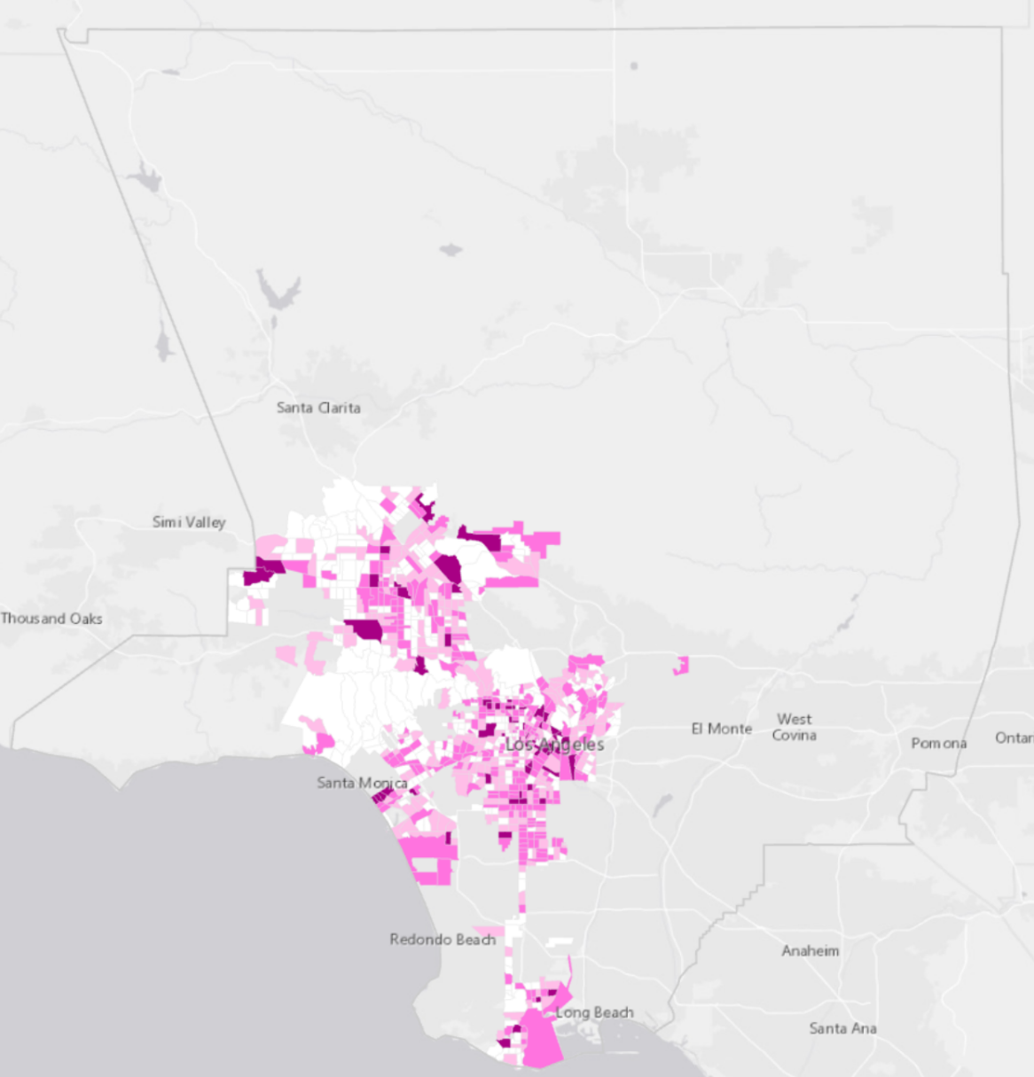

Based on the legend, the tracts with a Street Strategy Index larger than 606 are the best candidates for focused intervention.

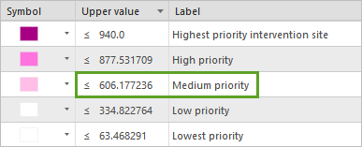

1. Add a field to the Additional Resources layer named StreetStrategyFlag with a Field Type of Short. Initialize this new field to zero.
2. Run the [Select Layer By Attribute](https://pro.arcgis.com/en/pro-app/tool-reference/data-management/select-layer-by-attribute.htm) tool to select tracts where Street Strategy Index is greater than 606. Set the StreetStrategyFlag field to 1 for the selected tracts.
3. Clear the selection. Save your symbology as a new file named StreetStrategyMap.lyrx.

**Step 6. Identify locations that optimize multiple objectives**

Next, you'll perform a spatial overlay to identify tracts providing opportunities to address more than one planning scenario objective.

You set the flag fields to 1 when a planning scenario objective was met. You'll create a field to sum the number of objectives met for each tract.

1. Add a field with the following parameters:
   * For Input Table, choose Additional Resources.
   * For Field Name, type NumObjsMet.
   * For Field Type, choose Short.
   * For Field Alias, type Number of Objectives Met.

Next, you'll calculate the sum.

1. Run the [Calculate Field](https://pro.arcgis.com/en/pro-app/tool-reference/data-management/calculate-field.htm) tool with the following parameters:
   * For Input Table, choose Additional Resources.
   * For Field Name, type Number of Objectives Met.
   * For Expression, type !SocialEquityFlag! + !AccessibilityFlag! + !RiskFlag! + !CentralizationFlag! + !StreetStrategyFlag!.
2. Symbolize the Additional Resources layer using the following parameters:
   * For Primary symbology, choose Graduated Colors.
   * For Field, choose Number of Objectives Met.
   * For Method, choose Manual Interval.
   * Change the first symbol to Cattleya Orchid, the second symbol to Fuchsia Pink, the third symbol to Rhodolite Rose, and the fourth and fifth symbols to Arctic White.
   * Format all symbols to have 0.25 point pale gray (Grey 10%) outlines.
   * For Upper value, change the first symbol to 4.0, the second symbol to 3.0, the third symbol to 2.0, and the fourth symbol to 1.0.
   * Change the first label to 4, the second label to 3, the third label to 2, the fourth label to 1, and the fifth label to 0.

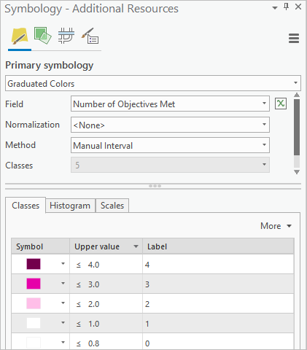

The darkest areas on the map meet the largest number of planning scenario objectives.

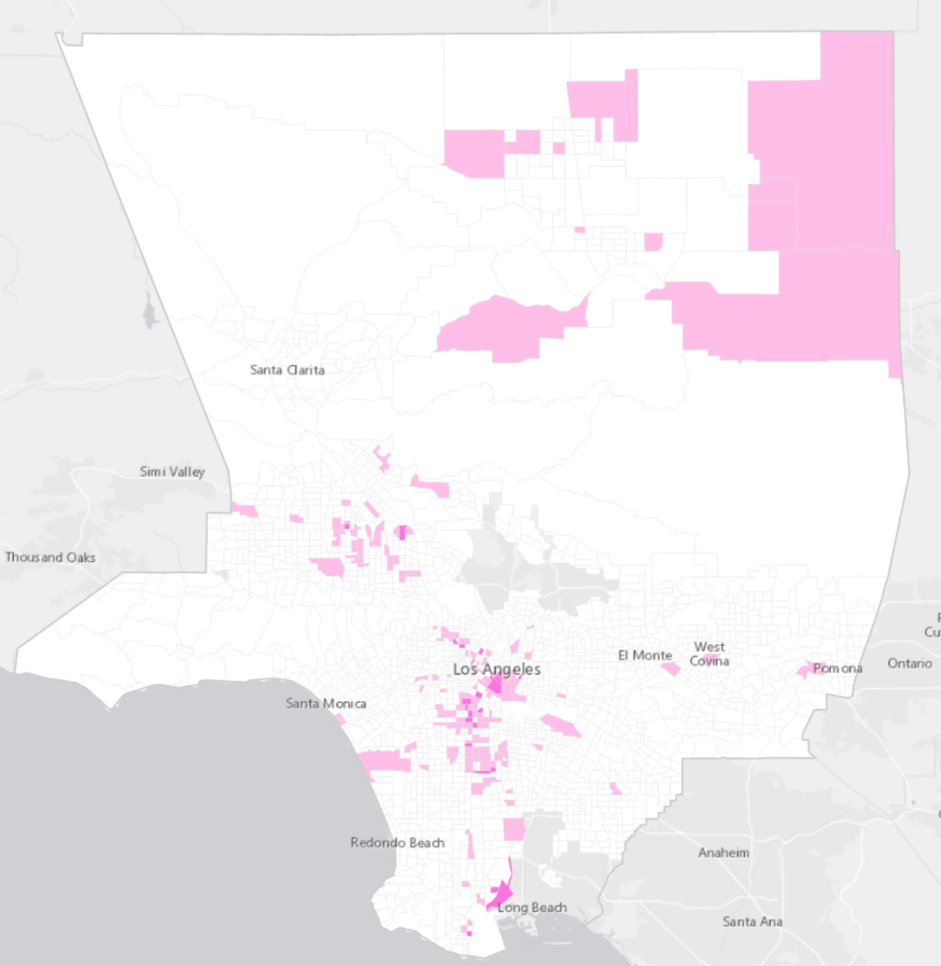

In this lesson, you created planning scenario maps optimizing different objectives. You then used spatial overlay to identify locations meeting multiple planning scenario objectives.

Only a few of the many possible planning scenarios are presented in this lesson. Mapping each one is important, not only for the spatial overlay at the end of the workflow, but also because maps provide an excellent foundation for open communication, collaboration, and building consensus.

The street strategy planning scenario presented here is powerful because it prioritizes intervention for the highest-crime, highest-complaint, and highest-cost locations. For this lesson, the analysis used 311 complaint data relating to homeless people or homeless encampments, crime data relating to homeless victims, and point-in-time count data for the number of chronically homeless people. If you have access to EMS call data for homeless individuals or crime incidents involving homeless perpetrators, the map for this planning scenario will more accurately reflect the most vulnerable homeless populations and locations where addressing homelessness can have the biggest impact on costs.

**Conclusion**

This lesson provides a glimpse into the homelessness crisis taking place throughout Los Angeles County. It outlines strategies to help cities, agencies, and spatial analysts understand, prevent, and manage homelessness. Key to prevention is knowing where people are becoming homeless. By completing each workflow, you learned how to analyze risk factors to create a risk map for new homelessness. You also learned a strategy for prioritizing locations for prevention programs. Using charts and maps, you explored differences among homeless communities. Understanding how shelter options and the factors contributing to homelessness vary puts you in a better position to recommend targeted aid and support. Finally, you created maps showing different planning scenarios for homeless resource investment. Overlaying the planning scenarios revealed locations that meet multiple planning scenario objectives. These, and other workflows, will be needed to effectively end homelessness. [or at least to reduce it]

A Storymap of the results of this exercise is provided here: [View final result](https://www.arcgis.com/apps/Cascade/index.html?appid=0c56e846dacb4663926cdbc8570ea4f6).

**Acknowledgements / References**

Homelessness data was compiled from the [Los Angeles Homeless Services Authority](https://www.lahsa.org/), the [Los Angeles County Sheriff's Department](http://www.lasd.org/), the [Los Angeles County GIS Data Portal](https://egis-lacounty.hub.arcgis.com/), and [DataLA](https://data.lacity.org/).